Emily Graber
Music 249 Reactions to the Record
Acoustic Reproduction of Violin Timbre and Articulation

Introduction

Being able to access and analyze historical recordings has improved our understanding of 19th and 20th century performance practice and taught us about the dissemination and dilution of musical styles over time. Of course, such study must be done carefully to avoid oversights or misunderstandings about the recordings. Sometimes our modern perspectives cause us to beg questions that are not relevant or assume points that are not founded. Piano roll specialists have become particularly aware of the fact that recorded data can be inaccurate. Piano roll manufacturers, for example, varied in their ability to isolate and quantize dynamics over the range of the piano and to transfer masters to mass cuts. When such imprecisions convolve with the state of some reproducing pianos today, the results can be garish and misleading.

Similar issues also affect acoustic recordings. Before we make conclusions about acoustic recordings, we must consider the conditions they were made in and goals of the artists being recorded. Authors do frequently acknowledge that prior limitations in recording technology impacted performances at the time they were made and impact what we hear today, but they stop short of explaining the musical significance of such limitations. If you are skeptical, consider the following. According to Peter Copeland, a broadcast he once heard described how musically literate listeners though they heard different artistic interpretations of a single performance when one version was "deliberately distorted until it sounded like an acoustic recording" and one version was unaltered (Copeland Manual, p. 4 2008 about BBC Radio 3, Settling the Score, 4 July 1999).

Is it not important to know what could have been lost in the translation from air to shellac, and how that loss could affect our understanding of the style enshrined therein? While it is impossible to know "how the performance on a recording might differ from what was done in the concert hall the day before," (Philip, In the Age, 231) or the exact intentions of a performance confined (or even unconfined) by recording restrictions, it is possible to characterize what recorded sounds psychoacoustically do and do not contain. Given such a characterization, one can know which musical features are affected, and the the implication of those features in performance analysis. For the remainder of this paper, I will be addressing the components of violin playing that are susceptible to translation errors - namely timbre and articulation - and the ramifications of their mistranslation.

In Part 1, I will discuss what information is missing and why. In Part 2, I will present a case study of Bronislaw Huberman's performances of Canzonetta for the purposes of analyzing the timbre and articulation, and in Part 3, I will discuss how improving the timbre and articulation in his recordings could change the resulting analysis.

Part 1: Recording Limitations

Modern recording techniques have developed and improved a great deal since 1877, the time of Edison's Tinfoil Phonograph. Today there are numerous microphone designs, differing in sensitivity and polarity, which collectively give sound technicians as much control over the quality of the captured sound as they want. Acoustic and early electric recordings however, suffered maladies of limited frequency and dynamic range. Artists reported having difficulty "keeping back ones natural volume of tone and reducing the scale all around, subduing accents and restraining attack lest some unpleasant sound be produced and magnified." (Mme. Fachiri, Gramophone, Dec. 1928)

It wasn't until 1940 that Decca could record frequencies up to 14kHz (Copeland, 26), still 6kHz shy of the upper bound of human hearing. Prior to this, record companies were certainly aware of sound quality issues, though they often accredited their records with spurious capabilities.

"These records are 'True-to-Life.' They reproduce faithfully every detail of technique and every subtle gradation of tone. Every detail of the words or music is as clear as if heard from 'the best seat in the Hall.'"
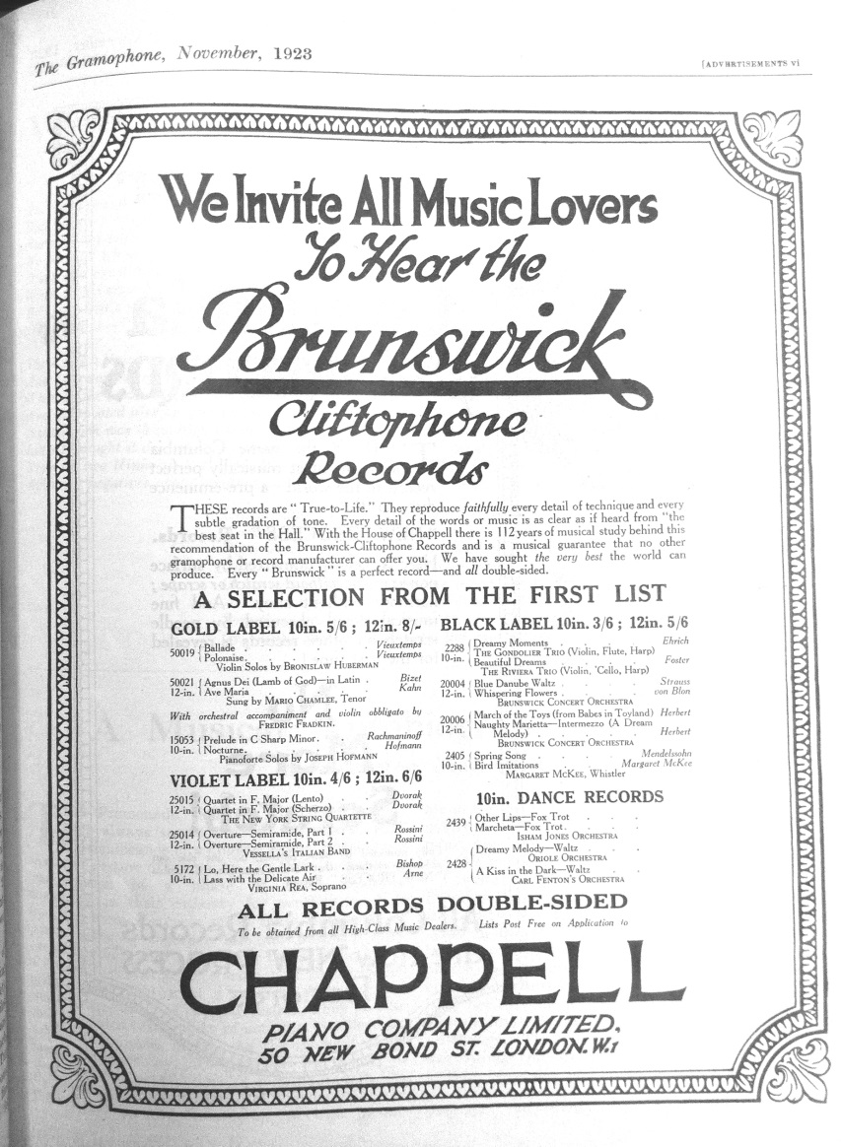

Despite the claims that Brunswick flaunts in its first appearance in The Gramophone in November 1923, the frequency range of its records does not exceed 4kHz until after 1925 (Copeland, 25). Certainly today, it is often the case that noise on the records masks data above 4kHz even if it is there. Still, the data above 4kHz is not negligible. The following clips can serve as a simple demonstration of what data remains above 4kHz.

Here is a clip from a 1923 Brunswick record with all frequencies below 4000 removed; we don't expect to hear anything recognizable because of masking and the limitations of the 1923 recording technology: See Website

Here is a modern recording with the same frequencies removed; coherent data is audible: See Website

Violin, the solo instrument in these examples, has a harmonic structure which extends well above 4kHz; in the early recording, there are no intelligible remnants of the violin's sound. In the modern recording however, it is easy to hear upper partials, and it would be even easier to hear them in a loud, unmuted passage. (After listening, don't forget to lower the volume on headphones especially.) The clarity of the partials has to do with both the modern recording equipment and the sensitively of our ears to frequencies in that range. The graph below shows equal loudness curves for various initial intensities.

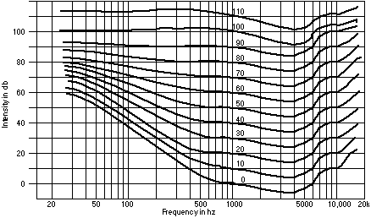

At 4000 Hz, each curve is at a minimum. I.e. from a given starting point, say 80 dB and ~36 Hz, the sound intensity level needed to create the same "loudness" sensation at 4000 Hz is only 65 dB, 15 dB below the intensity we started with. In other words, our ears are most sensitive to frequencies around 4000 Hz. For perspective, the natural harmonic A7, played on the E string in the usual spot of A5, has a fundamental frequency of 3520 Hz. Because violinists rarely play higher fundamental frequencies than this, record companies circa 1920 were able to capture at least those frequencies in the violin's range. However, the full harmonic structure of the violin's sound, responsible for the timbre of the instrument, was not captured. This causes the quality of high pitches on records we hear today to be lower than the quality of pitches with lower fundamental frequencies. In the youTube video of the very record I will examine later, the quality difference between relatively low and high notes is stark.

The 4000 Hz cutoff not only limits the reproduction of violin timbre, but also limits the reproduction of bowing and fingering articulations which have broadband, noise-like qualities.

Here is a completely unaltered, modern recording [R1]: See Website
Here is the same recording with the 4000 Hz cutoff [R2]: See Website

The likeness to "older" recordings is apparent when the cutoff is applied! I.e. R2 sounds older because its higher frequency content is missing.

In R1, the performer sounds close, and clear. The playing is quiet but full of subtleties. When notes are sustained, the timbre does not sound static. Most importantly, the gesture that was used to create the sound is somehow communicated to the listener. We can tell which notes are up-bows, how quickly the bow direction changes, how much pressure is applied, and the distance between the bow and the bridge. Such timbral and articulative features of the sound live in the high frequency range of the recording. In R2, the performer sounds distant. Differentiation between the violin solo and the orchestra is blurred. What was quiet playing is now inaudible at times. The beginnings of the melodic notes sound rounded and held back or placed in a efforted way. Timbral nuance is stabilized and bowing gestures seem too similar. Fortunately, the recording has almost no noise, so we can still hear small changes in the dynamics.

Knowing that tone and articulation must be affected in acoustic recordings as they were above, I wonder what of them are still audible in such recordings. In Part 2, I will present a case study of Bronislaw Huberman's performances of Canzonetta, the piece that has appeared repeatedly in my examples, in order to address his recorded tone and articulation.

Part 2: Analysis & Comparison

Introduction by Review

Bronislaw Huberman (1882-1947) was a Polish violinist recognized for his talent at a young age and well known for founding the Palestine Symphony Orchestra after World War I. Before Huberman's political agenda was in full swing (c. 1930), he toured extensively throughout Europe and America. Huberman began recording for the Brunswick-Blake-Collender Co. in October of 1921, after which time many reviews follow. The reviews are usually what one would expect of a successful invitee of Adelina Patti, a prodigy who brought Brahms to tears, and a former student of Joachim (and his assistant). Sometimes however, his reviews are surprisingly critical and curt. All may help us understand the style of his playing.
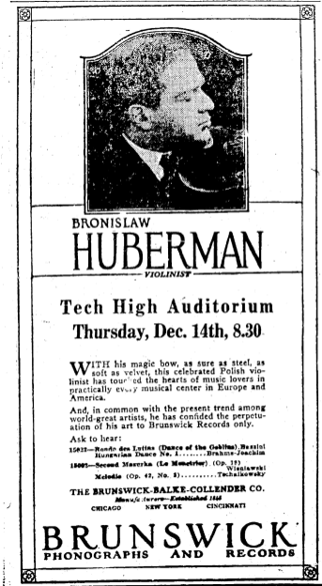
The Brunswick ad to the right was published in a Pennsylvania newspaper in December, 1922. (Paper: Patriot; Date: 12-12-1922; Volume: 83; Issue: 296; Page: 2; Location: Harrisburg, Pennsylvania) The ad was undoubtedly constructed with its pecuniary benefits in mind, yet the comments must have had some basis. Huberman's bowing abilities were obviously noteworthy to someone.

In the November 1923 issue ofThe Gramophone (a few pages after Brunswick's first 'True-to-Life' appearance), the 'Review of Records' by James Caskett reads,

"Unfortunately we have only received a small selection from the first batch of Brunswick records...put on the market in October; but they give a foretaste of what we may expect --some really valuable additions to the library. The recording is extremely good, Huberman's playing of the Ballade andPolonaise of Vieuxtemps (violin with piano accompaniment) being especially brilliant (50019; 12-inch Gold Label, 8s.)."

Descriptions of other artists follow for a short paragraph but none are as complimentary as are those to Huberman. (E.g. "Mario Chamlee...makes a start with Agnus Dei...") Indeed, this is The Gramophone's first Huberman-Brunswick double-tribute. Adulations of Huberman's playing and the reproduction of his playing are echoed repeatedly in later reviews (despite the apparent shortcomings of the recordings pointed out in Part 1).

It should be noted that not all violinist were explicitly named or praised for their abilities. In December 1923, Caskett he wrote of Strockoff, "An excellent double-sided violin record and extremely cheap at 4s. 6d." In his defense, Strockoff does manage to appear once in his composer-brother's Russian Wikipedia page. In January 1924 Caskett wrote,

"The violin is an instrument that usually reproduces well, but on the Brunswick records it is exceptionally good. It is, indeed, hard to imagine a more adequate record than the present one. Now let the Brunswick Company give us a serious piece of violin music."

The review in this case completely glossed over the performer, Max Rosen. Though, it is noteworthy that Brunswick's recording and reproducing abilities were apparently above average.

For Huberman, a surname mention was the norm. The December 1923 review of the Brunswick-made Kol Nidrei record reads, "Huberman's remarkable virtuosity is reproduced with incredible faithfulness. This is one of the finest violin records I have heard." That Caskett explicitly chose to address Huberman's actual performance again avers that Huberman's playing was something of a spectacle. The worst of Huberman's early record reviews seems to be from February 1924: "An Exquisite record." Of course that exact record (50031, Capriccio Valse and Romance) is listed as the "Best Violin Solo of the quarter" two months later.

In a Letter to the Editor in February of 1924, the first interrogations of Huberman's tone surface. H. Cecil Saunderson wrote,

"In comparing the violin tone of [Huberman's recording] with the violin tone obtained by other [record] makers, I find many points in favour of the Brunswick record and many points in favour of other makers. Brunswick has succeeded in giving equal volume of tone to both upper and lower registers and the tonal quality itself is, on the whole, more powerful and much more even than is the case with other makers. However in obtaining these results, admirable, of course, in themselves, they have lost entirely the mellow roundness of tone which nearly all other makers obtain satisfactorily, Brunswick tone being exceedingly metallic. Now I wonder whether any of you readers have any explanation to offer. Personally, I am almost convinced that Huberman is playing a Stroviol or similar violin with which all the music emerges through a trumpet, and not through "f" holes; the result, of course, being metallic tone, compensated by evenness and clearness, with uniform volume from the top of the E string down to the open G."

Whether Saunderson wrote out of dissatisfaction or benign curiosity is speculation; we can learn however, that listeners were attending to the sound of records, and not just the musical interpretation preserved by the records. To compare the sound of a Stroh violin and a regular violin in the same recording, listen to the video to the right. See Website

In June 1924, Percy Passage wrote:

"I can thoroughly recommend this record from the Symphonie Espagnole. Huberman's playing is clear and easy throughout, and always musical, and he makes a very vital thing of the rhythm of the rondo. It may be said that the work is 'fiddler's music,' but if so, why not? It is one of the best things of its kind that exists. I only regret the absence of the orchestra. This would have added enormously to the interest, especially in such places as the opening of the Rondo. I would make a similar criticism with regard to the Gluck record, which was originally written for flue and orchestra. The violin, of course, takes the flute part, and in other respects I have no criticism to make. The playing is exquisite. TheHungarian Dance is a Czardas, perhaps the most popular form of national dance in Hungary. If, as I believe, Huberman is a Hungarian, this explains his inspired interpretation."

Passage probably did like the "exquisite" playing on the records, but his longing for the orchestra could belie his positive reception. Perhaps the recordings were somewhat boring, needing an injection of "enormous" interest. As it turns out, his was not the first such criticism of Huberman's recordings.

In May of 1924, the review of Canzonetta and La Clochette also expressed mixed feelings about Huberman's playing and the sound of the recording. Caskett wrote,

"This seems to me particularly fine playing and recording, though one misses the orchestra in the Tchaikovsky badly, as Tchaikovsky depends so much on his orchestral couloring, the thing he did best. The Paganini is a piece of virtuosity pure and simple, and needs to be played by a master like Huberman to give complete satisfaction. Note especially the clear double-stopping, which is absolutely in tune."

Huberman's playing is still privileged, but the reviewer's lionizing is based on virtuosity, not on more subtle qualities like coloring, which incidentally ware found lacking in the Canzonetta accompaniment. Had Huberman's coloring been sufficient, I think that the reviewer may not have faulted the Tchaikovsky; however the accompaniment was blamed, suggesting that the recording of Canzonetta was not fully satisfactory. Were Huberman's abilities, or lack of abilities, responsible? Perhaps the limitations of the recordings were betrayed by Canzonetta, the tuneful and softer-charactered second movement of the Tchaikovsky Violin Concerto.

It is no wonder then, that all of Huberman's records mentioned so far contain at least one highly virtuosic piece. (However, it is noteworthy that all but one record also has a cantabile piece.)
- October 1923: Ballad and Polonaise by Vieuxtemps
- December 1923: Dance of the Goblins by Bazzini and Hungarian Dance No. 1 by Brahms
- December 1923: Second Mazurka by Wieniawski and Melodie by Tchaikovsky
- December 1923: Kol Nidrei by Bruch and Mazurka by Zarazycke
- February 1924: Capriccio Valse and Romance by Wienawski
- May 1924: Canzonetta by Tchaikovsky and La Clochette by Paganini
- June 1924: Andante and Rondo by Lalo
- June 1924: Melodie by Gluck and Hungarian Dance No. 7 by Brahms
If virtuosic pieces recorded and reproduced better, then they must have been essential for good reviews. But reviewers also knew when they were being fed "fiddler's music." The paradox is that listeners and reviewers wanted substantive music, but when substantive music was recorded and released, it was criticized for its sonic shortcomings which were due, in large part, to the recording capabilities of the time.

One K. Maszkerisky, a violinist retired by injury, wrote (April 1924):

"...it seems to me remarkable that out of the enormous number [of records] produced there should be so little of pertinent value an interest. ...the difference between great violinists and mediocre ones is not in the way they play rubbish but in the way they play master-pieces. ...no doubt it is largely a matter of fault with the gramophone companies. The red label mania seems to obsess them. ... We wish perhaps to buy a record by Kreisler. What has he recorded? We look at the catalogue, and the first thing we see isUnderneath the Stars...We hastily look further up the page, and encounter The RosaryHeavens! Perhaps there will be something better over the page. We turn it--Beautiful Ohio Waltz. And this by the greatest violinist in the world!"

This was written just before electric recordings made it possible to record long works with large ensembles (which tend to be more "pertinent"). But even amplified recordings were not immune to sonic criticisms. The following was written in February, 1928:

Huberman's record of a Carmen Fantasia (Brunswick 10254...) is disappointing. His playing is satisfactory enough, and I have no special quarrel with the selection, but the recording makes the tone seem dead, the high notes are attenuated almost to vanishing point, and the piano reproduction is not nearly up to modern standards."

Of course, not all of Huberman's criticisms were based on sonic reproduction. There were those who felt that Huberman and/or his playing were fundamentally flawed sans recording technicalities. The reviewer of Huberman's November 1929 version of the Tchaikovsky Violin Concerto wrote,

"He is not so impressive in that which demands subtlety of address. He rather lacks variety of tone, but is on the whole a good sound interpreter for this kind of music, which seeks to please rather than edify."

The reviewer was probably implying his dislike of the Canzonetta in particular, because it unquestionably demands the most "subtlety of address" of all the concerto's movements. Moreover, we can be sure that his remarks are not about the quality of the recording because, earlier in the review, he explicitly said that Huberman's tone was recorded better in the Canzonetta than it was in the other movements. Furthermore, according to the reviewer, "[Huberman] and the orchestra are recorded in a highly superior way." Therefore, Huberman's actual playing must have provoked the comment.

Another well-known critic is violinist Carl Flesch. Flesch provides the following in his 1957 memoirs (p. 176-178),

Two factors are decisive if we wish to judge a violinist objectively: his technical grounding and his particular personality. Huberman's technique, though sound, has always betrayed the fact that he left school too early. His technical basis is that of the 1890's. He holds the bow in the old manner, employs a pure finger vibrato without participation of the wrist, and intonates semitones pianoforte-like, according to equal temperament--a circumstance which becomes particularly and unpleasantly striking in his unaccompanied Bach. In tonal respects, too, he follows the tradition of his childhood in as much as he sacrifices smoothness and evenness of tone production, which in our time is an absolute necessity, to extravagant characterization; in other words, he either 'scrapes' or 'whispers'. His bowings again, excellent as they may be in themselves, leave much to be desired from the tonal point of view. Unreserved praise, on the other hand, is due to his runs and passage work, the precision and verve of which meet the most fastidious requirements.
Musically, too, his style gives occasion for serious criticism. The fact that he was left to his own devices at an all too early stage shows in his frequent neglect of elementary rules of articulation, especially in the form of wrong accents. Above all, however, it is the over-emphasis he lays upon his own personality as distinct from the work of art, that characterizes both his good and his bad performances...

Flesch's remarks have been questioned by Hans Keller--as he points out, Flesch was discussing Huberman circa 1900. By the 1920s, Huberman's playing could have developed significantly. On the other hand, the memoirs were written in 1957, so Flesch was probably aware of Huberman's mid-to-late-career playing at the time of his writing.

To summarize, Huberman was known for his virtuosity. His interpretations of sensitive music were less well received due to the sonic quality of his actual playing or the sonic quality of the recording of his playing (or both). Regardless, we know that listeners commented on and questioned the faithfulness with which the violin tone was reproduced. To address Huberman's tone production, I will continue by analyzing his three recordings of the Tchaikovsky Canzonetta.

Tchaikovsky Canzonetta

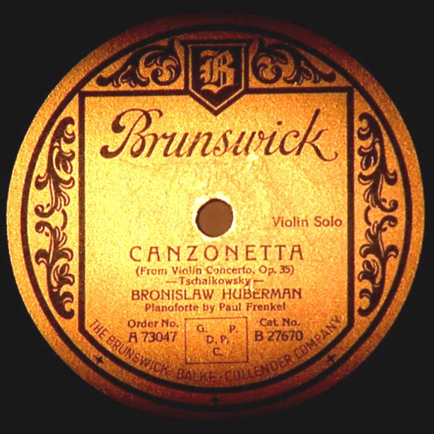
In December of 1922, Huberman recorded Canzonatta for Brunswick in their New York studios (Brunswick Records Discography, Vol 1, p 118). The record may have been released in 1923 as part of "The Hall of Fame Series" a 12 inch, gold label series started by Brunswick when they began making all double-sided records. By May of 1924, the first review of Canzonetta appeared in The Gramophone (quoted above). There are some inconsistencies in the documentation of the recording. For example, the Brunswick Record Discography specifies that the recording was of solo violin. Paul Frenkel, the pianist who accompanied Huberman on the Canzonetta (according to the record label of a later release B27670), is not mentioned in the Discography until January 1923. In that instance, the pair was documented as having recorded Capriccio Valse and La Clochette (Brunswick Records Discography, Vol 1, p 119). La Clochette was the other work on the Canzonetta record.
See Website for recordings
The Brunswick 1923 recording must have been made without amplification. The recording begins with the violin solo, cutting the 12-bar introduction in the score. With an additional cut at the end, the whole movement takes just under 4'30". One may wonder if the tempo that Huberman chose was influenced by the space on the record; In a recording from 1946, Huberman played the uncut movement in 5'45", yet the excerpt that is analogous to the 1923 recording was unchanged, 4'30", suggesting that he did not have to rush during the 1923 recording. Interestingly, in his 1928 recording with the Staatskapelle Berlin, the movement is 6'06", but the analogous excerpt takes only 4'25". It is noteworthy that this particular recording (1928) was made "when his career was at its height," according to Jerry Miller in the Music & Arts' liner notes.

Brunswick
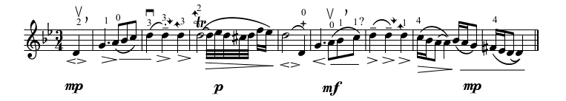
Brunswick-1923 first phrase: See Website
I have reproduced the first phrase of the violin's part as I hear it. The most obvious layer of markings has to do with Huberman's bow direction and slurring. He begins on an up-bow, and there is a slight discontinuity before the downbeat. In the second full measure, the first two quarter notes are in the same bow stroke. The second quarter note is separated from the first (indicated by staccato) but is itself sustained (indicated by legato). Measure 3 and 4 are each in their own bow stroke etc. The quarter notes in measure 6 are in the same stroke, but the bow is never stopped. Instead, the two quarters are articulated by bow speed. I have indicated the bow speed with hairpin markings or flat lines just below the staff. When a hairpin is opening, Huberman's bow speed is increasing; when a hairpin is closing, Huberman's bow speed is decreasing. These markings are usually, but not always, accompanied by a crescendo and diminuendo respectively.

Lastly, I have indicated the most likely fingerings and their articulations. The pickup sounds darker in color than the first downbeat, so I believe it must have been played on the G-string while the downbeat was played on the D-string. The eighth notes in the first full measure clearly begin with an open A, and there are no shifts for the rest of the measure. Skipping to bar 3 for a moment, we can hear that all of the pitches are played in one positions. The fingering is therefore forced to begin on the second finger, which is also arrived at by upwards slide. These constraints clarify the second measure which has audible slides as well. I believe Huberman actually uses the same finger throughout the measure! In measure 4 there is a barely-audible left-hand pizzicato, used to make the open D-string speak more quickly. Bar 7 has a consistent timbre, so I believe it is played on a single string. Finally Huberman crosses to the darker sounding G-string on the last downbeat to finish the phrase.
This recording has an intense sound. Huberman's note groupings are placed and loud. The articulations at the beginning of each bow stroke seem to be masked. The music feels very deliberate-not particularly gentle or sweeping. The vibrato is extremely consistent, the trill is mechanical, and the phrase is segmented. Huberman does not use portamenti, even in bar 4. (He does use some portamenti later in the movement.) The sound of the violin is very direct, i.e. there is little or no reverberation between bow strokes. Interestingly, the timbre of the different strings manages to come through in the recording despite the recording! Individual notes however, seem to have static timbres. If anything changes within the span of a note, it is the dynamic, not the tone. Throughout, it seems as though Huberman is playing quite loudly. The note groupings are heavy, as if Huberman's full arm weight is involved in the bowing motion, but the heavy bow changes that must accompany heavy bow strokes are not present.

The video below (see website) combines the Brunswick recording with metronome markings. The previous diagram has also been reproduced for convenience. Excluding some major rubato moments (Huberman greatly elongates the first pickup and the trill's ornaments), the tempo averages to 53 beats per minute. For all measures but measure 5, the first beat is longer than the second beat. This tempo lilt might explain why the phrase as a whole feels so deliberate and notewise. Huberman rushes through the eighth notes in measures 1 and 5, compressing the quarter note duration from 44 to 66 beats per minutes and 53 to 71 beats per minute respectively. Finally, Huberman sometimes lands ahead of the piano part (beat 2 of measure 2 and beat 1 of measure 5).

Columbia
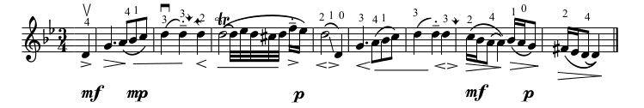
Columbia/Pearl-1928 first phrase: See Website
The affect of Huberman's interpretation does not change hugely in his 1928 recording. However, his bow articulation is slightly more clear. Especially in the second half of the phrase, his bow strokes speak quickly. Most of the rearticulations are accompanied by convenient fast-to-slow bow speeds that make the music feel very deliberate. It should be noted that timbre changes within the span of a note are now audible. Particularly in the downbeat of measure 1, the tone thins as it becomes quiet. In measure 6, the last beat has a distinctive tight timbre compared to the two preceding beats.

Huberman's fingerings are also different. The first pickup has an unusually wide wide vibrato, and the next downbeat has a brighter timbre. When the timbre changes again on beat 3 of measure 1, Huberman must be playing on the A-string. This implies though, that the first pickup was a fourth finger on the G-string. Because fourth finger is weaker than the other fingers, it seems an odd choice to start with. In bar 4, there is a large portamento that was not present in the 1923 recording. The glissando does not sound continuous, so Huberman must have crossed strings in the middle (by sliding part way on the A-string with second finger and part way on the D-string with first finger). Huberman apparently ends the phrase on a fourth finger as evidenced by the timbral change on the last note.

In the video below, the average tempo is 54 beats per minute; this is close to the average tempo of the 1923 recording, but the time is spent slightly differently. For the first 4 bars, the downbeats are longer than the second beats. In the second half of the phrase, the downbeats are actually slightly faster than the second beats. As before, Huberman rushes the eighth notes in measures 1 and 5, but the quarter note is compressed to an even greater extent, jumping from 45 to 71 beats per minute and 56 to 75 beats per minute respectively. In the Columbia recording, the penultimate bar is much faster than it is in the Brunswick recording, kicking off at 53 beats per minute. In fact, the whole phrase is a (tiny) bit of an accelerando from start to finish. In the Brunswick recording, the phrase pulls back in the penultimate bar to finish where it began.

1946
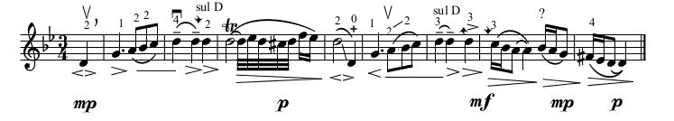
1946 first phrase: See Website
In the 1946 recording, the most remarkable feature is the overall tempo, which averages at 58 beats per minutes. The eighth note rushing persists, but it loses its rhetorical profile as the quarter-note compression is rather inconsistent. In measure 1, Huberman compresses the last beat from 60 to 66 beats per minute, while in measure 5 he compresses the last beat from 57 to 80 beats per minutes. The phrase is a ritardando overall, ending about 10 beats per minute slower than it began. Excluding the rubato-ed pickup and trill, the tempo ranges from 46 to 80 beats per minute! In 1928 the range was 45 to 75 bpm, and in 1923 it was 44 to 71 bpm.

Because it is such a late recording we are not surprised by the audibility of timbral changes within a single note. In the downbeat of measure 1, the spectrum is changing so quickly that we almost hear a squeak. Huberman's bow must have been sliding laterally toward the bridge to excite such partials.
While I acknowledge the differences between the recordings, I do not feel that Huberman's interpretations across the years are fundamentally different. There are certainly similarities between the recordings. The rush and lag within individual bars for example, seems to be a constant trait in Huberman's interpretation. The fast-to-slow bow strokes are also consistent. The rubato on the trill in 1946 is a bit more unwieldy than its predecessors, but I believe Huberman may have found himself with too little bow to linger on the ornament. (He was 64 at the time.) I am tempted to say that the change in tempo contour over time (steady in 1923, accelerando in 1928, ritardando in 1946) was a result of the piano or orchestra with which Huberman was playing but not necessarily the forces of modernization. The latest version does not have the characteristics of a "modern" orchestral interpretation, i.e. steady tempo, slower tempo, precise and intentional shaping for every note etc.

Modern Recordings
Sony-2005: See Wesbite
For comparison, let's consider Joshua Bell'srecording of the Tchaikovsky Violin Concerto (Sony, 2005 - with the Berlin Philharmonic conducted by Michael Tilson Thomas). The first phrase is soft, delicate, and emotional. Bell's playing seems to take no effort, and every bow stroke is legato. Every bow stroke also speaks right away, but Bell fights the temptation to pull convenient, quick strokes. The timbre is shimmery and nuanced. The balance in Bell's recording is so refined that listener's cannot help but feel the sadness in the music, or at least in the first phrase of the solo.

Bell's playing is very different from Huberman's loud and direct playing. Evidently there was something of a "grain" change between Huberman's and Bell's recordings. The Mahler syndrome seems to have affected Bell's interpretation too; the tempo for the first phrase averages just under 49 beats per minute, four beats slower than Huberman's slowest tempo, and spans only 20 beats per minute. In the second full bar (the bar with all quarter notes) Bell's tempo is 47 beats per minute! In Huberman's 1946 version, that same bar is played at 59 bpm, though it is 55 bpm in 1928 and 1923. Because that bar has such a regular rhythm, I find that its tempo inordinately influences my sense of the speed of the phrase. I.e. I think Bell's interpretation feels even slower than it it due to his tempo in bar 2 and the slight ritardando overall. The complete violin solo takes Bell 4'54" while Huberman never took more than 4'30".

Between Huberman's three recordings, we can hear the progress of technology and the changes in his musical interpretations. The relationship between the technology, his interpretation, and what we can hear today is complicated, but we can safely say that his concept of tone was is completely different from Joshua Bell's concept of tone. After 1946, recording technology continued to improve, so Huberman's best sounding recording is far from modern. Therefore it seems reasonable to ask if we can learn more about Huberman's tone by somehow improving his recordings. As Part 1 showed, the frequency cutoff of early recordings can completely flatten timbral nuance and dissolve the beginnings of notes. Since this is partially what characterized Huberman's earliest Canzonetta, we can assume that his tone was more nuanced and his bowing more continuous in reality.

By using his later recordings for reference and sanity check, it should not be too difficult to restore the sound quality of his earliest Canzonetta. It may even be possible to do similar work for other, earlier violinist. Part 3 will discuss methods for and potential outcomes of such restoration.

Part 3: Resynthesis & Reanalysis

One possible method for analysis-resynthesis was developed at CCRMA by Javier Saraaround 1989. The method essentially models the original wave in two parts, a deterministic, Fourier-based part, and a stochastic part. What sounds promising is the transition from a regular Fourier analysis to a deterministic-stochastic analysis. A Fourier analysis of a wave simply shows the frequencies and their amplitudes within the wave at any given time. By adding the components back together, the original wave is reconstructed. In the process of transitioning to a deterministic-stochastic analysis, noise in the wave would be modeled probabilistically, but would be perceptibly the same as the original wave when added back to the deterministic part. The probabilistic noise however, wouldn't contain the noise of the bow changes! By subtracting the probabilistic noise from the actual noise on the recording, we would be left with a cleaner recording that still has the noise of bow articulations.

Another nice feature of this method is that information can be added to either part of the analysis before resynthesis. I would likely add any partials predicted the frequency response of Huberman's violin to the deterministic part of the wave. This would enhance the timbre of the violin while keeping the resynthesis results objective. And luckily, Huberman's violin is still around; it has been played by Joshua Bell since 2001. For more information, see this article.

If such a resynthesis were done, I think the results could change our understanding of the Huberman's style and how recording influences style. We can almost be certain that Huberman's playing would sound more continuous, but it might also sound harsher due to bowing articulations. As always, more research should be done.

Appendix: Partial Discography

Bell wasn't the first to present the Canzonetta with modern aesthetics - Kubelik may have been the earliest to play the Canzonetta in a "modern" tempo. I wonder if there is a causal relationship between recording technology and interpretation speed? Perhaps the answer is yes for violinists. Louder playing is necessary for acoustic recordings, but requires more bow speed than non-loud playing. Faster bow speed limits the duration that a single bow can last, which ultimately influences the tempo of the piece. Maybe older recordings tend to be faster because of the recording technology. More research should be done, but it is still instructive to consider the following versions:

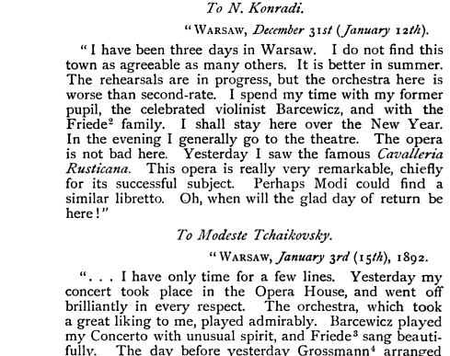

Barcewicz is perhaps the first violinist to have recorded Canzonetta (1905). His version is particularly of interest because he performed the concerto under Tchaikovsky's direction in 1892 (Tully Porter, Testament notes). He even received some interesting comments from the composer.

From what I can find, little is known is about Barcewicz. The Grove entry for Barcewicz is copied below. "(b Warsaw, 16 April 1858; d Warsaw, 1 Sept 1929). Polish violinist, conductor and teacher. He was a pupil of Apolinary Kątski at the Warsaw Music Institute (c1871) and then studied the violin at the Moscow Conservatory with Ferdinand Laub and Jan Hřímalý; on completing his studies in 1876 he was awarded a gold medal. From 1877 he played frequently in Poland and also in England, France, Germany, Denmark, Austria, Sweden, Norway and Russia. He taught the violin and the viola at the Warsaw Music Institute (1886–1918), where he also directed the chamber music class and conducted the student orchestra; he was a member of the governing Pedagogical Council (1888–1901) and later was appointed director (1910–18). He was leader of the Warsaw Opera House orchestra, and from 1886 was conductor there. In 1892 he established his own string quartet. Barcewicz was one of the finest Polish violinists. He won great recognition for his beautiful, deep, full tone, excellent technique and individuality of interpretation. He had a large repertory, comprising chiefly the works of Classical and Romantic composers." Gramophone also mentions him in April, 2004, pg 71 and Nov, 2007, pg 41. http://www.britishnewspaperarchive.co.uk/search/results?basicsearch=barcewicz in scotland

Barcewicz at A=440Hz: See Website
For those who are interested in pursuing the matter further, the same recording is copied here 5.9% slower. This drops the starting E to a D and lengthens the clip by 11.9 seconds.

Kubelik 1912 - scroll to the "Canzonetta from Violin Concerto" section.
Huberman 1923
More about Kreisler's 1924 Canzonetta.
About Flesch 1927
Huberman 1928
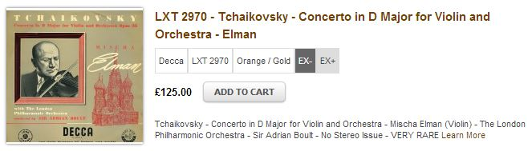
Elman 1929 - "His famous 1929 HMV set of Tchaikovsky’s Violin Concerto suffered in some quarters because Huberman had got in first on the rival Columbia label, and whereas the Polish violinist played the original score, albeit slightly cut, Elman naturally opted for the slightly modified Auer version. Nevertheless his full-hearted interpretation always had its admirers, who were prepared to put up with his little indulgences, and many were disappointed that the set was ousted from the catalogue after Heifetz recorded the work for HMV with the same conductor in 1937. " (http://www.naxos.com/mainsite/blurbs_reviews.asp?item_code=8.110912&catNum=8110912&filetype=About+this+Recording&language=English)
Hiefetz 1937
Huberman 1946
Elman 1954
Hiefetz 1957
Milstein 1962
Oisterkh 1966
Perlman 1978?
Vengerov 1995?
More information in Victor Discography
More information in WorldCat results.

Appendix: Bell 2010

Live-2010
A live recording of Bell from 2010 brings some interesting points to light. The violin sound is still quiet and delicate, but not quite as quiet and delicate as it was in the Sony recording. The average tempo is 51 beats per minute, as is the tempo in bar 2. With respect to this live recording, the Sony recording seems like a superperformance, a realization of the piece that might only be possible in recording. Nevertheless the forces of modernization are apparent in both (slow tempo, steady tempo, delicate and sad playing created by the careful shaping of every note.)
Project Proposal
First Outline
Summary of next step

References

Campbell, Margaret. The Great Violinists. Granada Publishing, 1980.

Copeland, Peter. Manual of Analogue Sound Restoration Techniques. The British Library, 2008.

Copeland, Peter. Sound Recordings. The British Library, 1991.

Day, Timothy. A Century of Recorded Music. Yale University Press, 2000.

Goetz, Helmut. Bronislaw Huberman and the Unity of Europe. 1967.

The Gramophone. 1923-1928.

Laird, Ross. Brunswick records : a discography of recordings, 1916-1931. Greenwood Press, 2001.

Oxford Music Online.

Philip, Robert. Performing Music in the Age of Recording. Yale University Press, 2004.

Serra, Xavier. "A System for Sound Analysis/Transformation/Synthesis based on a Deterministic plus Stochastic Decomposition". Stanford University, 1989.

Tchaikovsky, Modest. The Life & Letters of Peter Ilich Tchaikovsky. John Lane Company, 1906.

