JACKTRIP SETUP FOR SIMPLE PERFORMANCE BY TWO PARTICIPANTS October 2017 R. Edgar
(Macintosh OSX BASED):

Ensure both participants agree on setup. Below are suggested initial settings:
  - Sampling rate (48K)
  - Frames per packet (128)
  - Channel for local instrument audio (ch 1)
  - Channel audio from remote participant (ch 2)
  - Both computers have Ethernet-cabled connections (required for speed of connection, wifi is too slow)
  - Who will be server, who will be client
  - IP connection address for server
  - IP connection address for client
  - How to chat with each other during the session.
NOTES ON DETERMINING YOUR IP ADDRESS (for each computer)
- If you are connecting two computers on an internal network (i.e. not using the internet outside of your router, which you might do when initially testing JackTrip by yourself on two local computers):
Open your Mac System Preferences/Network dialog box:
Your internal network IP address, which you should use for this computer when both computers are connecting through your internal network, is listed as “IP ADDRESS” in this dialog. In the above example, this is “10.0.0.147”.
- If you are connecting two computers through an external connection (i.e. using the internet, such as you usually will when playing with a distant musician):

You can find your IP address by opening the Mac System Preferences/Network dialog box (below, right), or by using a web service like https://www.ipchicken.com (below left). Note that the address format is different for the external web connection; below it is 171.67.146.230.
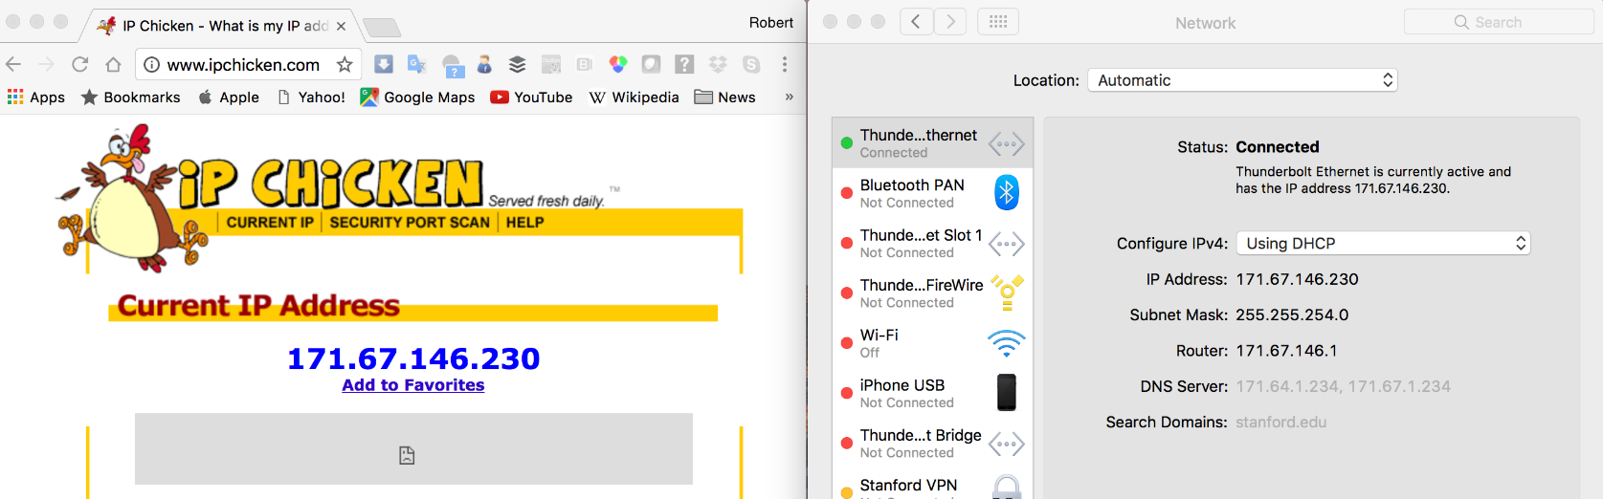

TALKING BETWEEN PARTICIPANTS DURING A SESSION:
You need to communicate verbally when you’re setting up your music sessions.
There are various ways of doing that. You can set up a microphone and use a conferencing software like Skype, multitasking on your cpu with JackTrip. Or, you can each use a smartphone, without connecting them to your computers, and just chat with each other in speakerphone mode.
It doesn’t matter, whichever you like. For this job aid, we will go with smartphones set to speakerphone mode. If you wish to substitute another approach, do so. Whatever is easier for you.

HARDWARE AND SOFTWARE SETUP PROCEDURES

Note: since JackTrip software is for two or more musicians playing together at a distance, you will be setting up a similar or duplicate system at each end of your connection. If you are trying JackTrip for the first time, you might want to set up two such systems in the same room, both connected to their own Ethernet port in a single router. If you are connecting to someone located at a distance from you, then the distant person will need to perform this setup at the same time.
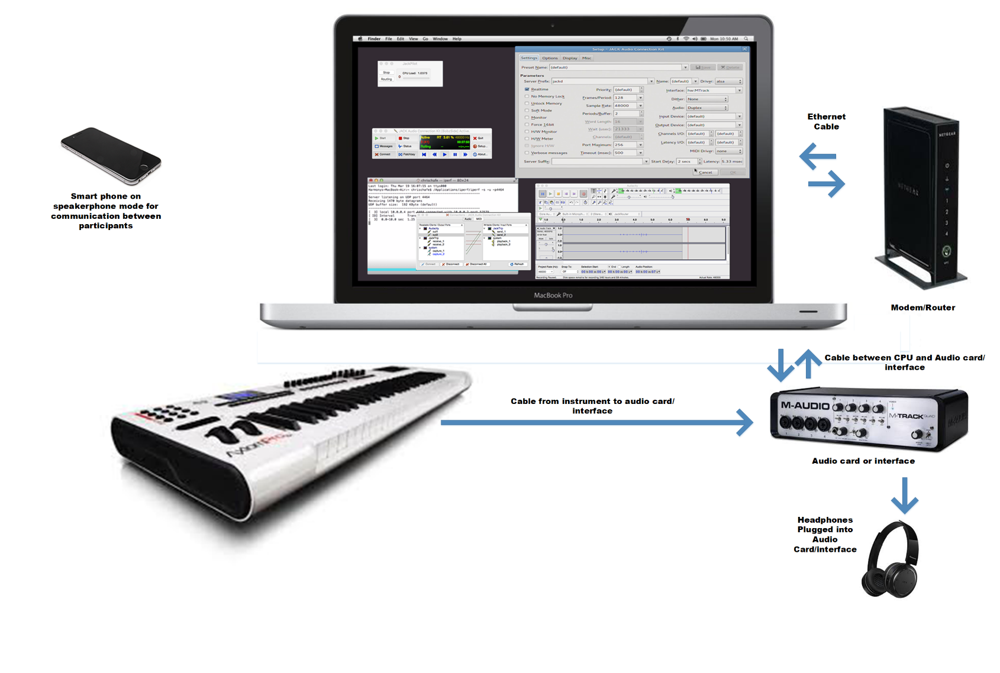
- CPUs: Connect to AC power; connect Ethernet cable for wired network connection.
- Connect audio card output to headphones (or a speaker).
- Start your computer.

- In the Mac System Preferences/Sound dialog, select your audio interface card for both the Input and Output device. In this instance, the Audio Interface is a “Sonic Port VX”:
- Set your Firewall settings to allow JackTrip to connect to it from a distant computer.
  - Go to Mac System Preferences/Security and Privacy:
  - In the lower left of the dialog box, click to open the lock to allow you to make changes. Then click “Firewall Options”.
  - You want to add jacktrip as software that will be able to receive incoming connections. Click the “+” button, then find jacktrip and add it. Remember to click the lock when you’re done, to prevent unwanted changes to your security.

- Open the JACK folder in Applications.

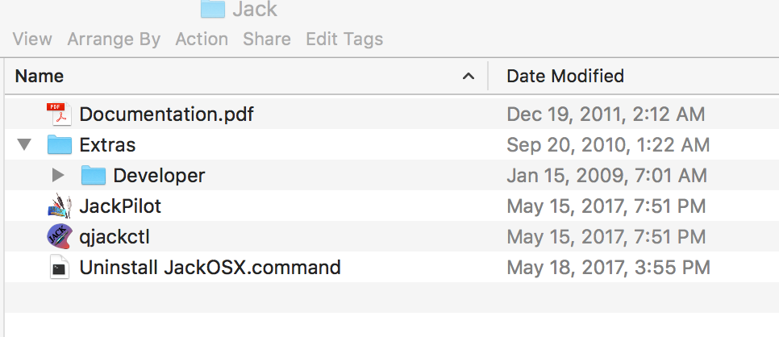

- In the Applications/Jack folder, double click qjackctl to launch it.

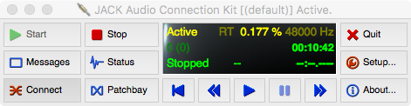

- Click the Setup button. The Setup dialog will open.
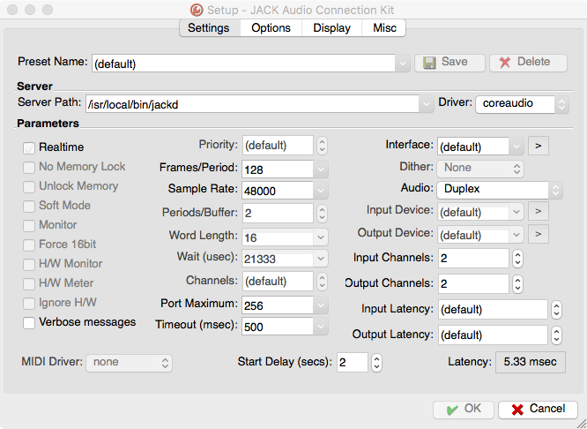

- Check qjackctl setup:
  - 48000 Sample Rate, 128 Frames/Period, 2 input channels, 2 output channels.
  - Set Driver to “coreaudio”;
  - Set Interface to your audio interface card using the > dropdown menu, where it should appear.

- Click “OK”.

- Click qjackctl “Start” button. The dark area should light up, it should say “Active”. It will also say “Stopped”. [NOTE: if an error message appears saying that Jack server could not launch, check and ensure that the “Server Path” field accurately leads to where you have downloaded “jackd”.]

- In your Applications folder, click Utilities, then double-click “Terminal”.

- Put your phone in speakerphone mode and call the remote musician (who should do likewise).

- You and your distant partner should have decided who would be the client, and who would be the server.
If you are the server, enter
jacktrip –s
in the Terminal window.
If you are the client, enter
jacktrip –c 10.0.0.47
(NOTE: substitute the IP address of the server for the number shown here)
in the Terminal window.

- The following should appear in the Server’s Terminal window, indicating that JackTrip is running:

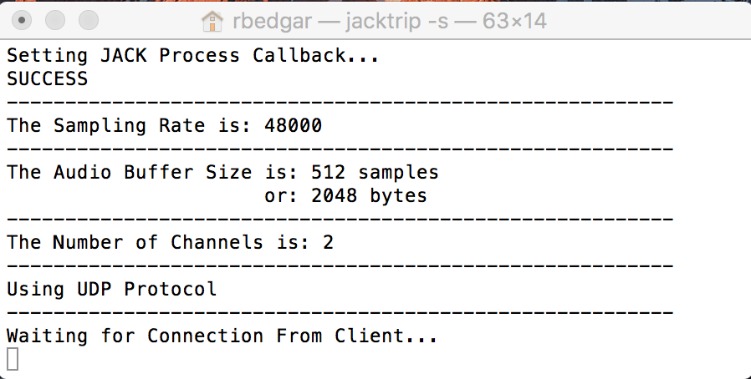

- On qjackctl, Click “Connect”. The “Connections” dialog should appear. It will look something like this, although the ports will differ because they will reflect the audio card/interface that you are using:

- Launch Audacity. In the Audacity Preferences screen:
  - Host should be Core Audio
  - Playback (output setting) on Jack Router
  - 2 (stereo) recording channels
  - Record (input setting) from JackRouter

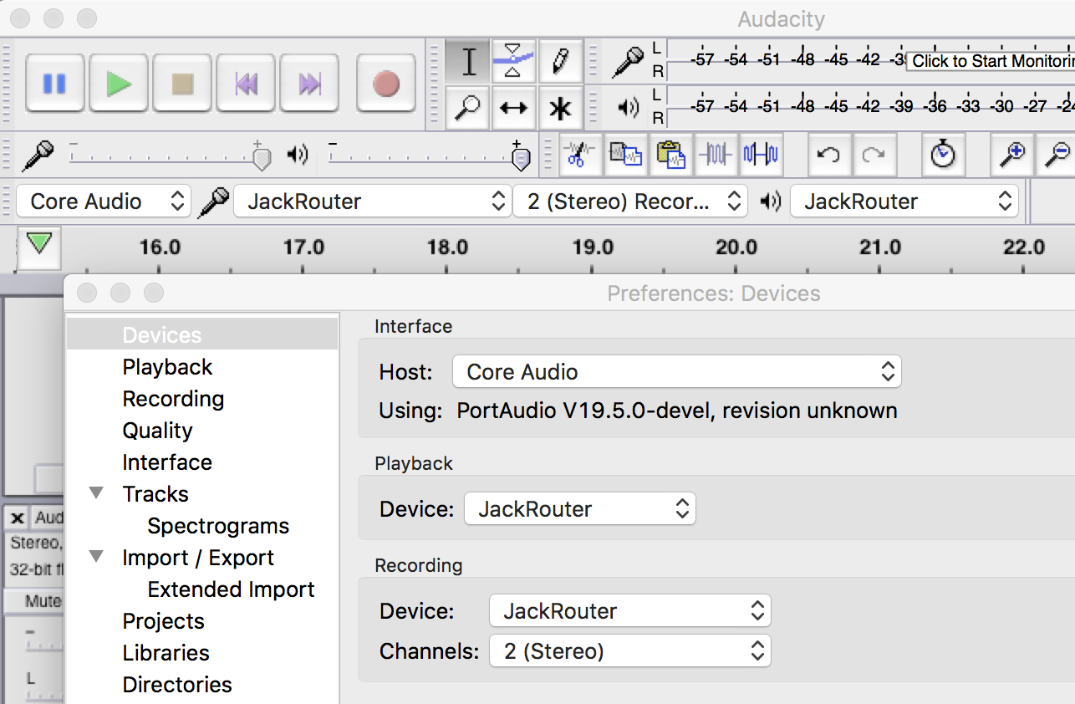

- In the physical world (not referring to software here): Plug your local instrument into your soundcard, and do the same with your headphones. Turn down headphone amplitude. Turn back up slowly while playing local instrument… should be channel one. The client should do the same, for channel two. The following images show the setups for both the Server and the Client:

- The Server should make the following connections:

NOTE the following:
    - Audacity input and output is set to JackRouter. Your audio card will still work with it.
    - Set the connections by selecting an item on the left, then its target item on the right, and then clicking “Connect” at the bottom left of the dialog. A line will appear between the two. Do this for each connection shown.
    - Press the Audacity “Record” button, and then also click “Pause” as shown above. You should be able to see the audio levels show to the right of the Mic icon, as shown above.
    - Play your instrument. If you’re the Server, your instrument level should show in L.
    - The Client should play his/her instrument. The client’s instrument level should show in R.

- The Client should make the following connections:
NOTE the following:
    - Audacity input and output is set to JackRouter. Your audio card will still work with it.
    - Set the connections by selecting an item on the left, then its target item on the right, and then clicking “Connect” at the bottom left of the dialog. A line will appear between the two. Do this for each connection shown.
    - Press the Audacity “Record” button, and then also click “Pause” as shown above. You should be able to see the audio levels show to the right of the Mic icon, as shown above.
    - The audio from the Server should be in track 1 (L). Audio from the client should be in track 2 (R).

When you’ve got the levels both working, you can click the Audacity “Stop” button to end your test recording.

When you’re both ready, you can each click your respective Audacity “Record” buttons, and start playing.

A FEW NOTES ABOUT JACK TRIP AND THE MACINTOSH:

- qjackctl has a “Patchbay” button and dialog. For your first setups, don’t deal with it. Leave it blank.
- One common problem is to have both the client and server terminal programs waiting for the other to connect.
- This is usually either a firewall issue (there is a firewall blocking the connection), or a case of having an incorrect IP address. Be sure you have opened your computer’s firewall to jacktrip. You may also have a firewall at your office. You’ll need to get through them all.
- Note that IP addresses take the form given in the pages above.
  - A local IP address takes the form 10.0.0.147. (some numerals may differ). This form is only used when you’ve got two computers communicating locally.
  - The IP address form you want is a “IPV4” format: 67.161.45.34 (numerals will differ). If the computers are connecting over the internet, this is what you need.
  - There is a newer IP “v6” address format that will look something like this: 2601:647:4e01:7bc6:250:b6ff:fed0:6031
This won’t work with jacktrip. You want the shorter IPV4 format.
- Another common problem is not setting the connections properly. Be sure that you have the Apple System Preferences for Sound set for your sound card. Be sure that the qjackctl Settings Driver is set to coreaudio; the Interface is set for your sound card; Audio: is set to Duplex. Also on the qjackctl Settings screen: remember that the Server signal settings should match those of the Client: Frames/Period (we suggest 128); Sample Rate (we suggest 48000), Word Length (we suggest 16). You won’t connect if these don’t match.

