Report to Barton Greene, Project Sponsor

December 12, 2002


3-D MIDI Controller

Group Number 50

Steven L. Backer
Arathi S. Bale
Lauren M. Luen
Joshua A. Thompson
William F. Wolcott

Table Of Contents

I. Executive Summary__________________________________________________ 3

II. Newsletter ________________________________ ________________________ 4

III. Project Report_____________________________________________________ 5

A. Introduction ______________________________________________________ 5

B. Background_______________________________________________________ 6

C. Product Requirements ______________________________________________7

D. Design Alternatives ________________________________________________ 8

E. Design Specifications _______________________________________________ 11

F. Design Description _________________________________________________ 14

G. Construction Details________________________________________________ 24

H. Costs _____________________________________________________________25

IV. User Instructions___________________________________________________ 26

V. Appendices _______________________________________________________ 31

- Appendix A: Technical Specifications __________________________31
- Appendix B: BasicX-24 Code _________________________________32
- Appendix C: P.I.M.P Research _______________________________ 39
- Appendix D: Preliminary Code _______________________________ 40
- Appendix E: Block Diagrams and Circuit Diagrams ______________41
- Appendix F: Project Reports _________________________________ 42
- Appendix G: Project Minutes, Emails and Receipts _______________43

Executive Summary

Objective
The objective of our project is to design and construct a three-dimensional MIDI controller.

Project Goals
- Develop a MIDI Controller which sends parameter level signals to a MIDI device based on the operator’s position in three-dimensional space.
- Each axis of motion will control one of three effect parameters via MIDI control change messages. The parameters are specific to each effect. (For example, a flanger effect has parameters frequency, depth, and rate).
- A self-contained microcontroller-based subsystem will transmit MIDI signals to an external device.
- The total cost for the system will not exceed $800.00.

Description

Musical Instrument Digital Interface (MIDI) technology has had a significant impact on music. Recently the research and development of non-traditional MIDI controllers at major universities and cutting edge institutions have led the market away from sliders and knobs towards more flexible means of control. Intrigued by the idea of alternative controllers and prompted by an idea from Tim Greene, our group decided to design and build such a controller. Our goal was to design a system which relies upon gesture for control and manipulation of sound routed through MIDI devices.

The P.I.M.P., Personal Interactive MIDI Performer, system utilizes accelerometers, which interpret acceleration in three dimensions. The three-dimensional accelerations are sent to the microcontroller, which calculates the relative change in position or orientation of the operator’s hand. The microcontroller sends MIDI control messages to the effects processor which changes its output accordingly. This product is designed in such a way that musicians may use it simultaneously with other instruments and is intended primarily for live performances.

A wireless enhancement to our sensing and transmitting unit (STU) to make our product completely hands-free was partially developed. However, due to signal power issues and time constraints, this addition could not be completed. Our original plan included translating three dimensional coordinates into MIDI messages. Due to the limitations of the accelerometers, any measurements of induced acceleration along an axis in three-dimensional space were negligible compared to the earth’s gravitational force. Measuring the tilt of the accelerometers with respect to gravity proved to be the best alternative.

All of the goals that this project initially entailed have been successfully met. However, the most viable follow-on project would be to improve our product by incorporating the wireless system found in STU. Such an improvement would increase the versatility and marketability of our product.

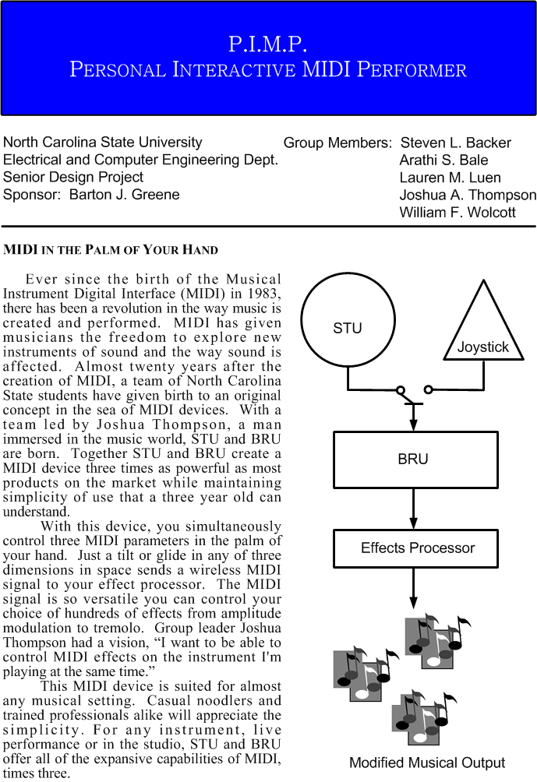

Introduction

The objective of this project is to design and produce a three-dimensional Musical Instrument Digital Interface (MIDI) controller. Our goal is to incorporate a sensing system, microcontroller, and effects processor to manipulate provided musical inputs. The sensing system implements accelerometers, which interpret acceleration in three dimensions. The three-dimensional accelerations are sent to the microcontroller, which calculates the relative change in position or orientation of the operator’s hand. The microcontroller sends MIDI control messages to the effects processor which reflect this change in the user’s position. This product is designed in such a way that musicians may use it simultaneously with other instruments and is intended primarily for live performances. The product moniker is P.I.M.P., Personal Interactive MIDI Performer.

This project was self-initiated by Joshua A. Thompson. Our sponsor is Barton Greene on behalf of the Electrical and Computer Engineering Department at North Carolina State University. His contact information is as follows:

Barton J. Greene
bjgreene@eos.ncsu.edu
Department of Electrical and Computer Engineering
(919) 515-8740 (Tel)
(919) 515-7382 (Fax)

The members on the project team are:

Steven L. Backer – MIDI and effects processor coordinator
Arathi S. Bale – Microcontroller and minutes coordinator
Lauren M. Luen – Microcontroller and document coordinator
Joshua A. Thompson – Project and interface coordinator
William F. Wolcott – Sensing and algorithm coordinator

Background

Over the last decade, emerging technology has become pervasive in the arts. Since the standardization of MIDI, technology has had a significant impact on music. Recently the research and development of non-traditional MIDI controllers at major universities and cutting edge institutions have led the market away from sliders and knobs towards more flexible means of control. Some of these alternative controllers incorporate gestural control while others may rely on one’s breath as input. A wide variety of sensing technologies are now utilized in MIDI controllers, ranging from accelerometers to infrared sensors to ultrasonic transducers.

Intrigued by the idea of alternative controllers and prompted by an idea from Tim Greene, our group decided to design and build such a controller. Our goal was to design a system which relies upon gesture for control and manipulation of sound routed through MIDI devices. Flexibility was a key tenant in our process.
Product Requirements

The product requirements can be broken down into the following subsections: general requirements, position sensing requirements, and enclosure requirements. Each of these subsections is addressed separately below.

General Requirements
- Develop a MIDI Controller which sends parameter level signals to a MIDI device based on the operator’s position in three-dimensional space.
- Each axis of motion will control one of three effect parameters via MIDI control change messages. The parameters are specific to each effect. (For example, a flanger effect has parameters frequency, depth, and rate).
- A self-contained microcontroller-based subsystem will transmit MIDI signals to an external device.
- The total cost for the system will not exceed $800.00.

Position Sensing Requirements
- The controller will include a relative position sensing system to determine the operator’s position in three-dimensional space.
- A push button user interface will be used to select the axis/axes on which to apply effects.
- The system will contain a defined connector and electrical interface for using other position sensing input devices in the future.
- The position sensor will be contained in a separate enclosure.

Enclosure Requirements
- The microcontroller will be contained in a single enclosure with a power input port, a 5 pin DIN (MIDI-OUT), and a secondary sensor connector.
- The accelerometers and transmitters will be in a separate enclosure.
- A printed circuit- or evaluation- board will be used for increased reliability and durability.
- The system will be powered by an external AC/DC converter.
- All buttons and ports will be clearly labeled for ease of use.

Design Alternatives

The design of the three-dimensional hands-free MIDI controller involved three major subcomponents: a position sensing input, a microcontroller, and an effects processor. Each of these three components was researched to determine the best alternative for the project’s applications. The alternatives considered for the different subcomponents of this system are discussed in detail below.

Position Sensing Alternatives

Several options were considered in choosing a device that can determine a position in three dimensions.

Radio Frequency
- Wide range of available products and technical support
- Project specifications require a small operating distance and consequently excessively high transmit/receive frequencies.

Ultrasonic
- Extremely costly
- Potential interference with adjacent sensors

Hall Effect (Honeywell HMC-1023)
- Three coordinate position
- Analog output
- Abandoned in lieu of sensor with digital output

Accelerometer (Analog Devices ADXL-202EB)
- Reliable duty-cycle digital output
- Two dimensional
- Adjustable output that provides the best configuration for the microcontroller
- The circuit design allows for a small and simple sensor enclosure.
- Free samples were available.

We opted to use the Analog Devices accelerometers as our position sensing input because of its versatility. Since the accelerometers are two dimensional, we decided to implement two of them in a perpendicular configuration.

Microcontroller Alternatives

The three most promising alternatives that were considered for the microcontroller component of this product were the Microchip PIC16F873, the Zorin HC11, and the NetMedia BasicX-24. The microcontrollers were primarily evaluated by considering its compatibility with MIDI, unit price, and programming language.

Microchip PIC16F873
- 40-pin 8-bit CMOS Flash microcontroller
- $4.84 for 27 microcontrollers
- Scarce information documenting its affiliation and use with MIDI applications.
- Assembly language programming

We decided not to select this alternative since there is insufficient information regarding the incorporation of the microcontroller into a MIDI environment. In addition, the assembly programming language for this microcontroller is very primitive and would be tedious to code.

Zorin HC11
- 8 channel 8-bit A/D capabilities
- MIDI Gizmo kit available
- C language programming
- $145 for microcontroller, $52 for MIDI Gizmo kit

This microcontroller offers extensive MIDI capabilities. However, in order to take full advantage of these capabilities, both the MIDI Gizmo kit and the microcontroller would need to be purchased. The high cost of the entire system deterred us from selecting this option.

NetMedia BasicX-24
- 16 I/O lines (8 lines with 10-bit A/D capabilities)
- Dual serial ports
- BasicX programming language
- $99.95 for the development kit
- Extensive documentation of its use with MIDI and ADXL-202AE
- Test code provided for this configuration

We opted for this microcontroller as we have prior experience with it. The BasicX language is easy to use for our programming purposes. The dual serial ports allow for easy testing and debugging of code. This microcontroller also includes features that allow for direct compatibility with other components. NetMedia published application notes for interfacing the BasicX-24 and Analog Devices’ ADXL-202AE.

Effects Processor Alternatives

Although not part of the actual controller, a MIDI effects processor had to be selected in order for us to demonstrate our product within the entire audio system. Since different manufacturers implement MIDI continuous controllers in various ways, the selection of an effects processor effectively tied our product design to that specific effects processor. Ideally, our controller would work with any effects processor, but this would be way out of the budget and scope of our five month project.

There are many effects processors with extensive implementations of MIDI continuous controllers, but most of these are high end audio equipment an order of magnitude out of our budget. Within our price range (less than $300), we considered three options: Alesis AKIRA, Behringer PRO DSP1224P, and the Lexicon MPX-110.

Alesis AKIRA
- 3 simultaneous continuous controllers
- Variety of effects
- Educational discount offered

The AKIRA was our ideal candidate for an effects processor. However, after many communications with Alesis, it was brought to the attention of their marketing liaison that this product would not be available until November 1st. Immediately, this seemingly perfect option had to be discarded.

Behringer PRO DSP1224P
- Continuous control of effects parameters
- Conflicting opinions regarding its response to three simultaneous continuous controllers

The PRO DSP1224P, made by Behringer, was also a highly considered alternative. However, after multiple conversations with technical and engineering support (we were even directed overseas at one point), it became evident that using this product could be disastrous. Despite data sheet claims, there were conflicting opinions from Behringer about the response from three continuous controllers, as set forth in our product requirements. The prevailing opinion and the datasheet seemed to indicate that this product was geared more towards only two continuous controllers. In addition, we discovered an explicit error in the datasheet relevant to our project that could not be explained by Behringer.

Lexicon MPX-110
- Dual channel
- Capable of responding to 32 continuous controllers
- Variety of options for mapping

The final option considered was the Lexicon MPX-110. This dual channel effects processor not only could respond to up to 32 continuous controllers, but also presented a variety of options for mapping the controllers to various aspects of its many effects. After negotiating to get this $250 product for $150, we decided on the MPX-110 for use in our project because of its extreme flexibility.

Design Specifications

A wireless position sensing system implementing accelerometers and transmitter/receiver pairs, a BasicX-24 microcontroller, and an effects processor make up the main hardware components for our system. A high level block diagram of our system is illustrated below in Figure 1.

Position Sensing System

Microcontroller
Effects Processor
Figure 1: Block Diagram of Entire System

Position Sensing System

The project implements the Analog Devices’ ADXL-202 accelerometers as the sensing device. The ADXL-202 measures acceleration on two axes and thus two accelerometers are required, set orthogonal to each other. The accelerometers’ specifications and circuit diagram are found on ADXL-202AE Specifications (Appendix A). Three outputs corresponding to each axis’ acceleration are sent to two ABACOM Technologies’ ATRT transmitters and one Ming Microsystems transmitter. The transmitters are three separate amplitude modulated signals operating at 419, 433 and 310 MHz respectively. The specifications for the ATRT transmitters are found in Appendix A. The signals from the AM transmitters have a range of approximately 250 feet, 100 further than the receivers’ range. The power supply is one standard 9 V battery adjusted to five volts by a 317 5V voltage regulator. The entire assembly will be mounted in a separate enclosure.

Microcontroller Specifications

Our microcontroller development kit includes a power supply, serial cable, BasicX programming software, and the BasicX-24 chip on an evaluation board.

Desirable microcontroller features:
- 16 I/O pins of which 8 have 10-bit A/D capabilities
- 65,000 instructions/second clock speed
- I/O speed of 30.27 kbaud on COM1
- 5V power regulator

COM1 serial port will be used for the MIDI interface as COM3 cannot transfer data at a rate fast enough for MIDI communications. The 5V power regulator will provide scaled voltage for both the accelerometers and the MIDI interface.

MIDI Specifications

Interaction between the microcontroller and the effects processor will be accomplished using the standard MIDI protocol, as outlined in the MIDI Manufacturer Association’s General MIDI Specification. In addition to the existing microcontroller and effects processor hardware, a communications interface must also be created.

The microcontroller’s code relevant to the output of MIDI messages should meet the following specifications:
- Messages are sent using a serial data port at a rate of approximately 31.25 kbaud.
- Each message should conform to the standard format of MIDI control change messages: one status byte followed by two data bytes.
- Each axis of motion is assigned to a specific continuous controller. Controller numbers 1, 2, and 3 are arbitrarily chosen for simplicity.
- The motions on each axis will be mapped to the value of the second data byte of each axis’s control message.

In the realm of hardware, MIDI messages should be sent over a standard MIDI cable connected to the MIDI-IN port of the effects processor. An interface to connect the serial output pin of the microcontroller to a 5-pin DIN receptacle is needed. Any voltage source needed in the interface will come from the on-board microcontroller power supply voltage.

Enclosure Specifications

This project requires two enclosures, one for the sensing and transmitting unit (STU) and one for the base station receiving unit (BRU).

The BRU enclosure was chosen with both style and functionality in mind. From a design perspective, we wanted to present a slim, sleek form to mirror the system inside. We also wanted a finished look, not an obvious prototype enclosure. Functionally, the BRU enclosure was chosen with adequate space to accommodate the required ports and user interface.

The STU enclosure was chosen solely for functionality. Since the accelerometers are extremely shock sensitive and will break if dropped, the enclosure must provide protection. We have chosen to use a hard plastic shell coated with shock resistant foam.

Design Description

Our product is designed to manipulate musical input according to the user’s position in three-dimensional space. The orthogonally positioned accelerometers provide three-dimensional accelerations to the microcontroller, which calculates tilt and generates MIDI control change messages. The accelerometers are housed with the transmitters in a separate enclosure (STU). STU is battery powered. The receivers are located on the microcontroller’s evaluation board, which is housed in BRU. A modified joystick serves as an alternate sensing system. The joystick was designed to act as a test aid. Our design includes an effects processor that changes the musical input based on the received MIDI messages. A high level overview of our product will be followed by detailed descriptions of these components. This section will conclude with an analysis of our test approach and procedure

High Level Overview

Our three dimensional MIDI controller consists of three major hardware components: Analog Devices’ accelerometers for sensing, a combination of ABACOM Technologies’ transmitter/receiver pairs and a transmitter/receiver pair from MING MICROSYSTEMS, and a BASICX-24 microcontroller. A block diagram of the major hardware components follows.

MIDI Output

Receivers

BasicX-24

Accelerometers
Transmitters
Battery
User Interface
Joystick
Power Supply

Figure 2: Configuration of Three Major Components

Our product has been designed to convert accelerations measured through tilting or moving STU into proportional MIDI values. Each accelerometer produces different tilt measurements depending on its orientation with respect to the force of gravity. In theory, when the accelerometer measures all of the gravitational pull as its tilt factor, a MIDI message of 127 will be sent to the microcontroller (the maximum value). Conversely, when the accelerometer measures zero gravitational force, a MIDI value of zero will be transmitted.

Sensing and Transmitting Unit Description

Two Analog Devices’ ADXL-202 two axis accelerometers provide the primary sensory input to the system. The ADXL-202 senses acceleration and distills the input into a pulse width modulated digital signal. The duty cycle of the output signal is proportional to the acceleration of the unit in the given direction. The period of the output signal can range between 0.5 ms and 10 ms and is set by a resistor between pin 2 and ground. We chose a resistance value of 125 kΩ to achieve an output frequency of 1.0 kHz. A capacitor was required for each axis at pin 6 and 7. We selected .39 uF capacitors for each axis. This value was calculated from Analog Devices’ ADXL worksheet to maximize bandwidth and resolution while minimizing signal noise.
Below is a circuit diagram of the ADXL-202 along with a screen shot of the Analog Devices’ parameter calculation program.

Parameters
Supply voltage |  | V
Analog Bandwidth | 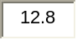 | Hz
Acquisition Rate |  | readings / sec
Resolution (g's) |  | g
Resolution  (deg of tilt) |  | deg. of tilt
Microcontroller  counter rate | 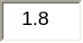 | MHz
T2 |  | ms
Power cycling % |  | % on time
T_{MAX} |  | deg. C
T_{MIN} |  | deg. C
Zero g drift Tmax |  | g
Zero g drift Tmin |  | g
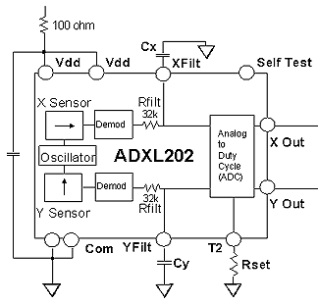

Component Values
Supply Decoupling | 0.1 | uF
C_{X}, C_{Y} | 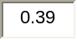 | uF
R_{SET} |  | Kohm

Figure 3: Circuit Parameters for Accelerometers

The three output signals from the ADXL-202 were input into three separate transmitters: two Abacom ATRT at 418 and 433 MHz and one Ming Microsystems 310 MHz transmitter. The Abacom ATRT has two pins, an input and a ground. These low power transmitters are designed to transmit using input signal power, however the Ming Microsystems transmitter uses the 5 V external power source.

Power is supplied to the unit via a standard 9 V battery. The voltage is adjusted to 5 V using a National Semiconductor LM317 adjustable voltage regulator. A power switch was connected to the negative terminal of the battery. An LED was connected in series with the switch as a power indicator. Below is a circuit diagram of the Sensing Transmitting Unit.

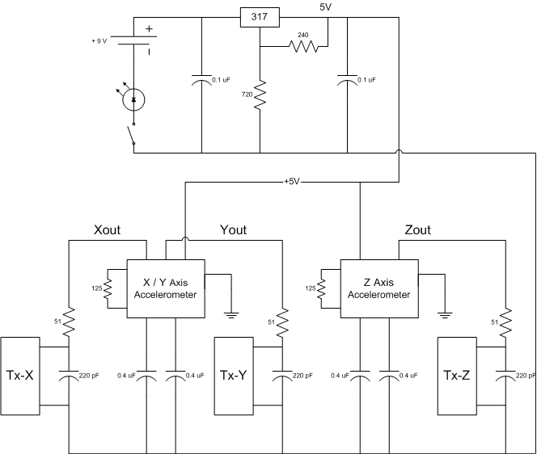

Figure 4: Circuit Diagram for Sensing and Transmitting Unit

Figure 4: Circuit Diagram for STU
In the end, the transmitter/receiver pairs were removed from the project to make way for a power and signal cord. The Abacom transmitters need a supply current of at least 6 mA which the Analog accelerometers could not provide. One wireless alternative would be to use a powered transmitter for all three axes. In order to have a functioning product at design day, a cord was attached with power, ground and three signal lines. Power is 5 V supplied by pin 21 on Basic-X.
Base Station Receiving Unit Description

Hardware

The hardware of the Base Station Receiving Unit can be organized into three parts: the receiver modules, the user interface, and the microcontroller.

The BRU centers on the BasicX-24 microcontroller. We obtained a BasicX as part of a development kit. The development kit also included a serial cable used for program downloads and a nine volt AC/DC power source. A software CD was provided for use with the microcontroller.

Certain features aided in the design of the hardware interfaces to the sensors and the effects processor. The BasicX-24 microcontroller is equipped with a five-volt power regulator that supplied power for the MIDI communications interface and the position sensing circuits. Eight of its sixteen I/O pins can function as analog/digital converters. We used these pins to handle the digital output from the accelerometers and the third axis (potentiometer source) from the joystick developed as an alternative input. A high-speed serial port provided a sufficient baud rate for MIDI communications. In addition, the evaluation board offered ample space for the other components without being too large.

The user interface is comprised of the foot pedal and the axis selection switches. The foot pedal switch circuit is a transistor based circuit designed to power an indicator LED while sending a digital signal to the BasicX. The digital input pins of the BasicX float high at +5 V, therefore the foot pedal is designed as a pull-down circuit. When the switch is engaged the LED is illuminated and the input pin is tied to ground.

The ABACOM and Ming AM receivers are the mates of the transmitters mentioned above, receiving at 433, 418, and 310 MHz respectively. The ABACOM modules are equipped to handle digital or audio signal with onboard filters to optimize both. We only used the data out port leaving the audio out unconnected. Unlike the transmitters, the ABACOM receivers required connection to +5 V and ground. The Ming receiver had only one output pin and also required power and ground. The outputs of each receiver were connected via three A/D pins to the BasicX, where the duty cycle was measured and the acceleration was calculated.

The description given above is how the system was designed. Ultimately, due to problems with the ABACOM transmitter/receiver systems, we connected the accelerometers directly to the BasicX using a cable. A complete circuit diagram of the final Base Station Receiving Unit is given below.

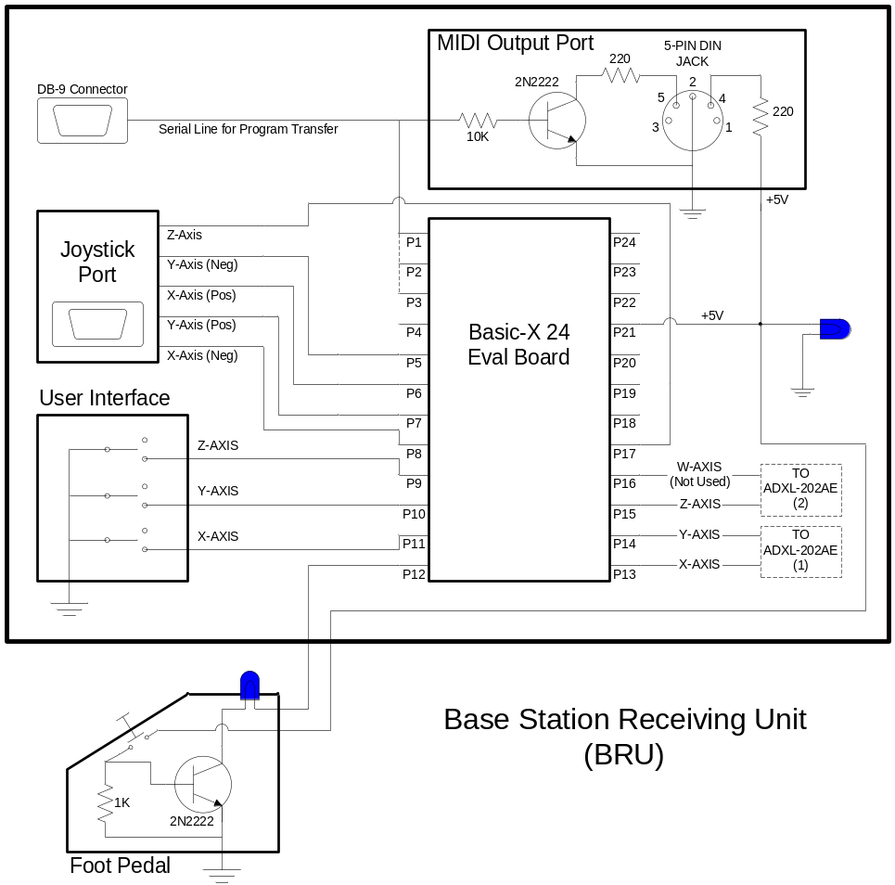

Figure 5: Circuit Diagram of Base Station Receiving Unit
Software

Our microcontroller code incorporates the use of an accelerometer sensor (STU) and an alternate joystick input. The sensor used for controlling MIDI output is selected in the DetermineSensor state. With the accelerometers, the tilt of each accelerometer is calculated and translated into a position. This position is then converted into a MIDI command and output to the effects processor in the OutputMidiCommands state. If the joystick sensor is selected, the next state to be executed is ChangeParameter. In this state, the change in position along a particular axis is scaled between 0 and 127. These eight bits are then sent to the effects processor as our second data byte. If six MIDI messages have been sent then the user interface is checked again for any changes. Otherwise, the program checks the status of the foot pedal. Figure 5 illustrates this whole process.

The foot pedal acts as an on-off switch. When the pedal is off a bypass MIDI message is sent rendering the original musical input. Three flip switches are used to select the active axes of control. If all three axes are switched off, then the joystick is enabled. Polling of the foot pedal and the user interface slowed down the execution time. Therefore, a pollcounter variable was included to accommodate for these timing issues.

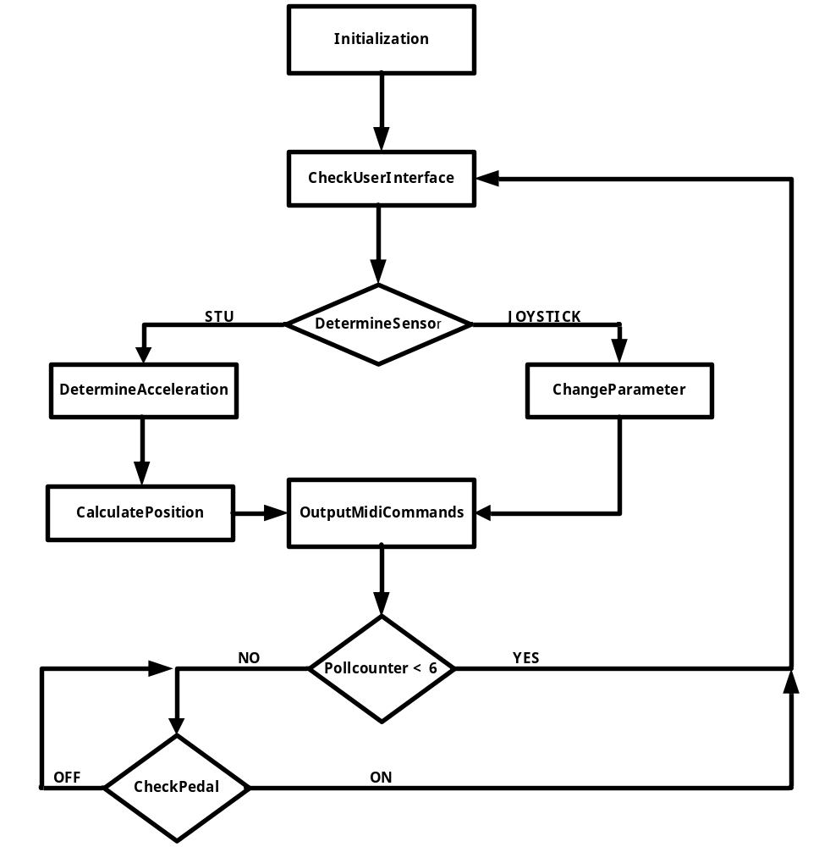

Figure 6: Microcontroller Flowchart

MIDI Implementation Description

Standard MIDI control change messages provide communication between the microcontroller and the effects processor. The discussion of the implementation of MIDI communication is divided into three parts: the hardware interface, configuring the microcontroller, and encoding of MIDI messages.

MIDI Hardware Interface

The hardware interface required to allow the BasicX-24 microcontroller to output MIDI messages is shown in the schematic below. The input to the interface is the serial data line on the microcontroller (pin 1), and the MIDI messages are output at a standard 5-Pin DIN Jack. The +5V supply voltage comes from the output of a 5V regulator found standard on the microcontroller development board (pin 21).

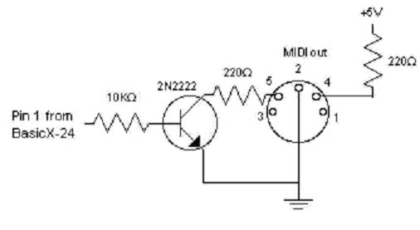
Figure 7: MIDI Output Interface

Configuring the Microcontroller Communications

The MIDI specification states that messages should be sent at a baud rate of approximately 31.250 kbaud. This requirement necessitated the use of COM1 on BasicX, as opposed to the use of the I/O pins through COM3 which is limited to 19.2 kbaud. The baud rate of COM1 is defined by the equation:

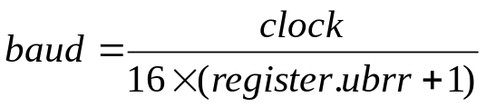

Solving for register.ubrr yields:

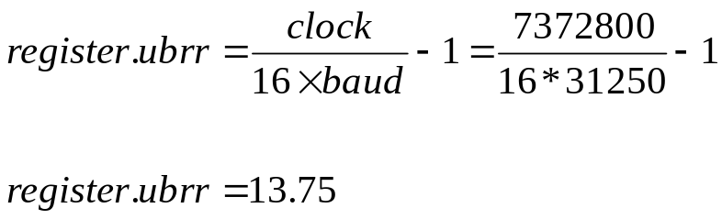

The register named ‘register.ubrr’ must be set to an integer value to adjust UART communications to the desired baud rate. Rounding up to a value of 14 yields an actual baud rate of 30.720 kbaud. For our purposes, this is sufficient and should work well with most MIDI devices.

The messages are sent using the BasicX ‘PutQueue’ system function to place the message variables (see below) into an output buffer. The output buffer is linked directly to COM1 through the ‘OpenCom’ system procedure. Please see Appendix B for actual BX-24 code.

Encoding of MIDI Messages

The microcontroller program code instructs the BasicX-24 to output MIDI messages via the serial data line (COM1). The types of MIDI messages being sent are defined by the MIDI standard as “Control Change” messages. Our effects processor (Lexicon MPX-110) allows for you to assign various aspects of its effects to a continuous stream of MIDI control change messages, also known as a “continuous controller (CC).”

The MPX-110 allows for a variety of mapping techniques for continuous controllers. For the purposes of this project, we chose to linearly map our tri-axis sensor input to three of the main controls on the MPX-110: ‘Mix’, ‘Effects Level’, and ‘Adjust.’ In addition, we set up our footswitch as a CC that could put the MPX-110 into a bypass mode, allowing only unprocessed sound to be heard. The continuous controllers must be “learned” by the MPX-110 as outlined by the section ‘Learning Continuous Controllers” in the MPX-110 user manual. However, this only needs to be done once. The MPX-110 will retain these settings even without power. For more information on continuous controllers and the MPX-110 controls, please refer the MPX-110 user’s manual as well as the user manual for this product.

MIDI Control Change Messages are composed of a packet of three bytes: a status byte, data byte 1, and data byte 2. The status byte tells the receiving hardware that a control change message will follow. The first data byte specifies the CC number, and the second data byte specifies the CC value. The full message is transmitted by sequentially sending each of the three bytes across a serial data line. Real time control of the effects processor is realized by continuously updating the value of the second data byte based on the sensor input, and then transmitting the messages at high speeds. The chart below defines the values of the byte-sized variables used to hold the value of each byte needed for the message.

Variable | Mapping | Value | Description
status | N/A | 0xB0 | Specifies control change messages on channel 1
data1X | X-Axis | 0x01 | Maps CC1 to the ‘Mix’ control on MPX-110
data1Y | Y-Axis | 0x02 | Maps CC2 to the ‘Effect Level’ control on MPX-110
data1Z | Z-Axis | 0x03 | Maps CC2 to the ‘Adjust’ control on MPX-110
data1Bypass | Footswitch | 0x04 | Maps CC4 to the ‘Bypass’ control on MPX-110
data2X | X-Axis | 0x00 to 0x7F | Value is proportional to the X-Axis acceleration.  Minimum acceleration = 0x00  Maximum acceleration = 0x7F
data2Y | Y-Axis | 0x00 to 0x7F | Value is proportional to the Y-Axis acceleration.  Minimum acceleration = 0x00  Maximum acceleration = 0x7F
data2Z | Z-Axis | 0x00 to 0x7F | Value is proportional to the Z-Axis acceleration.  Minimum acceleration = 0x00  Maximum acceleration = 0x7F
data2Bypass | Footswitch | 0x00  or  0x7F | Toggles bypass mode on the MPX-110  Footswitch OFF = 0x00 (Bypass enabled)  Footswitch ON = 0x7F (Effects enabled)
Table 1: Data Byte Values for MIDI Messages
Construction Details

Sensing and Transmitting Unit

For the construction of the sensing and transmitting circuit, we used a combination of solder and wire-wrap on perforated circuit board. Solder was chosen to make the regulator and battery connections more stable. Wire-wrap was used to connect the accelerometers and transmitters to the rest of the circuit. The size of STU’s enclosure required all components fit in a small space. The 9 V battery was covered in electrical tape to avoid inadvertent shorts from the battery shell. The perf-board was floated in the plastic sphere enclosure by a long bolt through the center. This design was constructed to minimize damage from shock of impact. All permanent cords were attached with strain relief.

Base Station Receiving Unit

The platform for the BRU is the Basic-X 24 evaluation board. The tinned-through board facilitated the construction of busses connecting power and ground to the MIDI and foot pedal circuits as well as the receivers. Both the MIDI and foot pedal circuits were soldered into place for sturdy construction. Wire-wrap was used to connect the receivers to facilitate trouble-shooting and repair. The Basic-X eval-board was mounted into a plastic enclosure. The enclosure was altered to accommodate ports, indicator and the user interface. Again the permanent cords were attached with strain relief.

The foot pedal switch is housed in an aluminum enclosure that is attached to the main BRU enclosure via a permanent cord. We chose a heavy-duty, lighted, latching, AC switch. The switch was altered to incorporate a DC indicator to match those used in STU and BRU.

Software

The BasicX-24 microcontroller is available as part of a development kit. BasicX-24 has its own environment: programming language and compiler. The compiler comes equipped with its own code optimization tool. Programs for this project were downloaded into the EEEPROM on the chip using the serial cable. The downloading procedure is simple. Once the code has been written and the evaluation board has been powered up and the serial cable has been connected, the user can select the compile and run option from the pull-down menu bar in the BasicX editor. This option will automatically load the new program into the EEEPROM. The program used for this project is entitled debugMerged.bxp. This program is included in Appendix B for your convenience.

Costs

Purchases | Costs
MIDI Documentation | 85.90
NetMedia Microprocessor (BasicX-24) | 112.95
Analog Devices Accelerometers (ADXL-202EB) | 0.00
Lexicon Effects Processor (MPX-110) | 165.00
ABACOM Technologies transmitter/receiver pairs | 186.22
MING Microsystems Inc transmitter/receiver pairs | 0.00
Speakers | 0.00
Cabling Connector | 11.00
Joystick | 0.00
Soundcard | 0.00
Polycase Enclosure | 7.00
Components and Connectors | 35.20
Foot Pedal | 8.00
Grand Total | 611.27
Table 2: Cost Analysis

The amounts provided in Table 2 include all incurred shipping and handling costs. The MIDI documentation was obtained from MMA: MIDI Manufacturers Association. The speakers, joystick, and soundcard were provided by group members. We ordered the cabling connector from Newark Electronics. Miscellaneous components such as resistors, op amps, and transistors were purchased at RadioShack. Our foot pedal was ordered from Digikey.

Our project requirements specified a budget of $800.00. As shown above, we have stayed well below this budget. We would not have been able to do so if Analog Devices had not been so kind as to provide us with accelerometers at no charge.

User Instructions

The Personal Interactive MIDI Performer (P.I.M.P.) is an alternative controller for MIDI devices. It has been designed specifically to control the Lexicon MPX-110 effects processor. This manual outlines how to set up, configure, and use the P.I.M.P. system

The P.I.M.P. system is composed of a main control box (hereafter referred to as BRU), an ON/OFF footswitch, a spherical sensing and transmission unit (STU), and an AC power adapter.

BRU Panel Overview

Axis Selection
Switches
Power LED

Rear Panel View

To Sensor Joystick Connector

MIDI Output To Footswitch

Top View

X Y Z

Front Panel View

PC Interface
Power Connector

Setting up the hardware

You will need the following components:

- P.I.M.P. controller system, including
  - BRU
  - STU (or optional Joystick)
  - Footswitch
  - AC Power Adapter
- One Standard MIDI cable
- Effects Processor (Lexicon MPX-110)
- Musical Instrument with 1/4” output plug (from DJ gear, guitar or mic amplifier, keyboard, etc.)
- Amplifier and Speakers

To begin, make the proper connections using the diagram below as a reference:

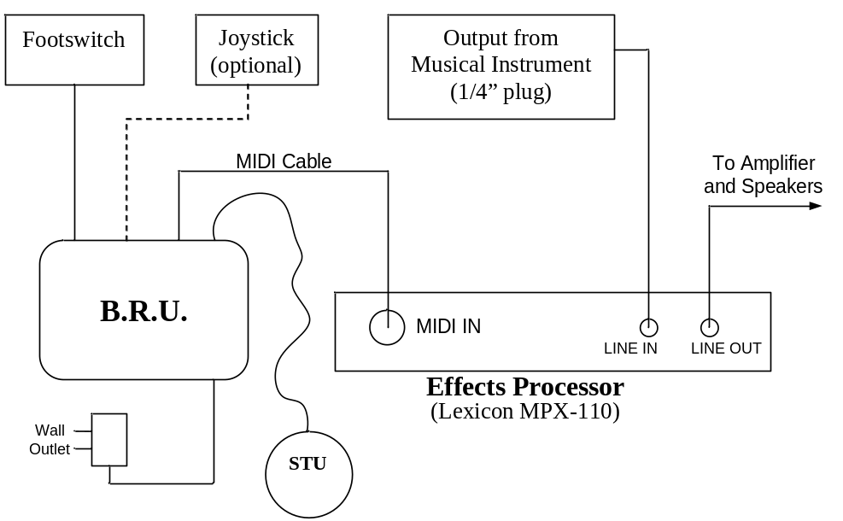

P.I.M.P. Connection Diagram

Configuring the Lexicon MPX-110

In order to use the P.I.M.P. controller with the Lexicon MPX-110 effects processor, you must configure the effects processor properly. This only needs to be done once, as the MPX-110 retains all settings even after the power has been switched off. The guide below is meant as a “quick start” set of instructions. For more detailed information, please the MPX-110 User Guide, section 5-6.

To configure the effects processor for use with the P.I.M.P:

1. Simultaneously press the Store and Tap buttons to activate Learn mode. The Store LED will flash slowly and the Tap LED will light to indicate that Learn Mode is active.

2. Adjust the “Mix” control on the front panel. Move the X-Axis of the P.I.M.P. controller through its full range, using the joystick or a computer program such as MIDI-OX. The Edit LED will flash to indicate incoming MIDI activity.

3. Press the Store button to commit to the assignment. The Store LED will flash quickly.

4. Adjust the “Effects Lvl / Balance” control on the front panel. Move the Y-Axis of the P.I.M.P. controller through its full range, using the joystick or a computer program such as MIDI-OX.

5. Press the Store button to commit to the assignment. The Store LED will flash quickly.

6. Adjust the “Adjust” control on the front panel. Move the Z-Axis of the P.I.M.P. controller through its full range, using the joystick or a computer program such as MIDI-OX. The Edit LED will flash to indicate incoming MIDI activity.

7. Press the Store button to commit to the assignment. The Store LED will flash quickly.

8. Press the “Bypass” button on the MPX-110. Then, press the footswitch twice (The LED should go off and on). The Edit LED will flash to indicate incoming MIDI activity.

9. Press the Store button to commit to the assignment. The Store LED will flash quickly.

10. Simultaneously press the Store and Tap buttons to deactivate Learn Mode.

Using the P.I.M.P. system

Once everything has been set up and configured as described above, the P.I.M.P. system is ready for use. Using STU (or the optional joystick), you can now control the ‘Mix,’ ‘Effects Level,’ and ‘Adjust’ controls for any effect on the MPX-110. Begin by choosing an effect to use, and starting the musical source (CD, guitar, etc.). Since the only requirement for a musical source is a line level signal via a 1/4” plug, virtually any musical instrument can be used as a source.

A great deal of flexibility has been built into the system. In other words, it was designed for people who like to experiment. Feel free to try out different things – connecting STU to a dancer, assigning different controls to the axes, giving the joystick to your 4-year old, connecting BRU to a computer sound program, or whatever else you can imagine.

Gestural Control

By using the supplied sensors (STU or the joystick), you can use your movements to control the sound.

STU is the standard controller for the system, and provides for very flexible gestural control of sound. Try experimenting by rotating the sphere as well as moving it. Both actions will affect the sound in different ways. Just like a musical instrument, you must practice using STU to gain a feel for how it works.

The joystick can also be connected to BRU simultaneously with STU, although only the joystick or STU can have control. The default sensor is STI, but the joystick may be used by selecting it through the user interface as described below.

User Interface

The user can select many options for how he or she wants to use P.I.M.P. The three axis selection switches located on top of BRU allow the user to turn on and off each of the three individual axes, or use any combination of the three. For example, if you only want to be able to control the ‘Adjust’ parameter of the MPX-110, you can turn off the Y and Z axes with the switches. The sensor unit (either STU or the joystick) will then have an effect on the sound only when moved along its “X-axis.”

When all three of the switches are in the OFF position (up), then control of the system on ALL axes is given to the optional joystick controller. The joystick itself controls the X and Y axes, while the rotating knob controls the Z axis. Using the joystick is very useful when setting up the MPX-110, or if you just want to try out another controller besides STU.

When the footswitch LED indicator is illuminated, the P.I.M.P. system has control. However, by pressing the footswitch, the MPX-110 can be put into a “Bypass Mode” during which the musical input source remains unaltered. That is, 100% dry sound is heard at the speakers. Pressing the switch again so that the LED comes back on gives effects control back to the P.I.M.P. system. This is very useful if you want to turn the effects on or off quickly during a live performance.

Optional Microcontroller Reprogramming

The microcontroller, which is the “brain” of the P.I.M.P., can be reprogrammed using a serial cable connected to the port with a small computer icon. Most users will wish to use the default programming of the Basic-X microcontroller inside. However, advanced users or engineers can utilize the flexibility of a programmable microcontroller by modifying or creating additional program code to enhance or alter performance.

Contact Information

Any questions or comments regarding the P.I.M.P. controller should be directed to one of the following people (the designers of the system):

Steven L. Backer - slbacker@unity.ncsu.edu
Arathi S. Bale - asbale2@unity.ncsu.edu
Lauren M. Luen - lmluen@unity.ncsu.edu
Joshua A. Thompson - jathomp2@unity.ncsu.edu
William F. Wolcott - wfwolcot@unity.ncsu.edu

Appendix A: Technical Specifications

1. MING Microsystems Transmitter/Receiver Specifications
2. ABACOM ATRT and AM-HRR6 Specifications
3. ADXL-202EB Specifications
4. NetMedia BasicX-24 Specifications
5. Lexicon MPX-110 Specifications
6. Polycase Plastic Enclosure Catalog
Appendix B: BasicX-24 Code

'Merged Program containing Joystick and accel code
'Last modified 11/25

'Define Pins
Const InputX As Byte = 13 'Assign X-axis input from sensor
Const InputY As Byte = 14
Const InputZ As Byte = 15
Const InputW As Byte = 16
Const Pedal As Byte = 12
Const Xbutton As Byte = 11
Const Ybutton As Byte = 10
Const Zbutton As Byte = 9

'Joystick Pins
Const JoyInputPosX As Byte = 7
Const JoyInputNegX As Byte = 8
Const JoyInputPosY As Byte = 6
Const JoyInputNegY As Byte = 5
Const JoyInputZ As Byte = 17

'Declare variables for input and output buffer
Dim InputBuffer(1 To 13) As Byte
Dim OutputBuffer(1 To 10) As Byte

Dim isBypassOn As Boolean, UseJoystick As Boolean

'Define states
Const CheckPedal As Byte = 30
Const CheckUserInterface As Byte = 32
Const SamplePeriod As Byte = 33
Const DetermineAcceleration As Byte = 34
Const CalculatePosition As Byte = 35
Const OutputMidiCommands As Byte = 36
Const ChangeParameter As Byte = 37
Dim State As Byte, NextState As Byte
Const DetermineSensor As Byte = 38

'Declare variables to store MIDI messages
Dim status As Byte
Dim data1X As Byte
Dim data1Y As Byte
Dim data1Z As Byte
Dim data1Bypass As Byte
Dim data2X As Byte, data2Y As Byte, data2Z As Byte
Dim data2Xold As Byte, data2Yold As Byte, data2Zold As Byte 'Check data2 for a changed value
Dim data2Bypass As Byte
Dim Dx As Single
Dim Dy As Single
Dim Dz As Single

'Declare axes variables
Dim X_axis As Boolean, Y_axis As Boolean, Z_axis As Boolean
Dim XZeroMsg As Boolean, YZeroMsg As Boolean, ZZeroMsg As Boolean 'See if (data2=0) has been sent

'Declare position variables
Dim X_pos As Integer, Y_pos As Integer, Z_pos As Integer
Dim X_old As Integer, Y_old As Integer, Z_old As Integer
Dim Time As Single, DeltaT1 As Single, DeltaT2 As Single

'Declare acceleration variables
Dim Ax As Single, Ay As Single, Az As Single, Aw As Single

'Declare other variables
Dim Period1 As Single, Period2 As Single
Dim PollCounter As Integer

'Timing Debug Vars
Dim StartTime As Long
Dim StopTime As Long
Dim SpentTime As Long

Public Function SensorPeriod(ByVal PinX As Byte) As Single
'This procedure measures the period for the ADXL202 accelerometer.

Dim SumT1 As Single, SumT3 As Single
Dim T1 As Single, T3 As Single, i As Integer
Dim AvgT1 As Single, AvgT3 As Single
Const NSamples As Integer = 5

SumT1 = 0#
SumT3 = 0#

For i = 1 To NSamples
Call PulseIn(PinX, 1, T1) 'High-going pulse
Call PulseIn(PinX, 0, T3) 'Low-going pulse

SumT1 = SumT1 + T1
SumT3 = SumT3 + T3
Next

AvgT1 = SumT1 / CSng(NSamples)
AvgT3 = SumT3 / CSng(NSamples)

SensorPeriod = AvgT1 + AvgT3 'Units are in seconds
End Function

Public Sub GetAccelerations(ByVal Pin1 As Byte, ByVal Pin2 As Byte, ByVal Period As Single, ByRef A1 As Single,
ByRef A2 As Single, ByRef Time As Single)
'This procedure reads each axis of an ADXL202 accelerometer. Both components of a 2D acceleration
'vector are returned. Units are in gravities.

Dim T1X As Single, T1Y As Single, A1temp As Single, A2temp As Single
Dim SumX As Single, SumY As Single
Dim i As Byte, T1 As Single, T3 As Single, Time2 As Single, Temp As Single, Temp2 As Single
Const NSamples As Byte = 5

SumX = 0#
SumY = 0#
Time = 0#
Time2 = 0#
Temp = 0#

For i = 1 To NSamples
Call PulseIn(Pin1, 1, T1)
SumX = SumX + T1
Call PulseIn(Pin1, 0, T3)
Time = Time + T3 + T1
Call PulseIn(Pin2, 1, T1)
SumY = SumY + T1
Call PulseIn(Pin2, 0, T3)
Time2 = Time2 + T3 + T1
Next

'Take averages for each axis
T1X = SumX / CSng(NSamples)
T1Y = SumY / CSng(NSamples)

'Determine the acceleration components
A1 = (((T1X / Period) - 0.5) / 0.125)
A2 = (((T1Y / Period) - 0.5) / 0.125)

End Sub

Public Sub Main()
'Initialize all inputs to the microcontroller
Call PutPin(InputX, bxInputPullUp)
Call PutPin(InputY, bxInputPullUp)
Call PutPin(InputZ, bxInputPullUp)
Call PutPin(Pedal, bxInputPullUp)
Call PutPin(Xbutton, bxInputPullUp)
Call PutPin(Ybutton, bxInputPullUp)
Call PutPin(Zbutton, bxInputPullUp)
Call PutPin(JoyInputNegX, bxInputPullUp)
Call PutPin(JoyInputPosX, bxInputPullUp)
Call PutPin(JoyInputNegY, bxInputPullUp)
Call PutPin(JoyInputPosY, bxInputPullUp)
Call PutPin(JoyInputZ, bxInputPullUp)

Time = 100000000# 'Needs to be a big number > 1min
DeltaT1 = 0#
DeltaT2 = 0#

'Initialize coordinate variables
X_pos = 0
Y_pos = 0
Z_pos = 0
X_old = 0
Y_old = 0
Z_old = 0
Dx = 0#
Dy = 0#
Dz = 0#

'Initialize boolean bypass flag
isBypassOn = False
UseJoystick = False

'Initialize Poll Counter
PollCounter = 0

'Initialize Midi Communications Interface
Call OpenQueue(InputBuffer, 13)
Call OpenQueue(OutputBuffer, 10)
Call OpenCom(1, 9600, InputBuffer, OutputBuffer)
register.ubrr = 14

'Initialize Midi Communications Message Bytes
status = 176
data1X = 1
data1Y = 2
data1Z = 3
data1Bypass = 4
data2Bypass = 0
data2X = 0
data2Y = 0
data2Z = 0
data2Xold = 0
data2Yold = 0
data2Zold = 0
Period1 = 0.00103
Period2 = 0.00103

'Initialize Midi Communications Zero Message Flag - used when one axis
'is turned off to indicate that a Midi value of zero has been sent
'(to prevent sending repetitous Midi messages of value zero)
XZeroMsg = False
YZeroMsg = False
ZZeroMsg = False

'Initialize State to initial state
NextState = CheckUserInterface 'CheckPedal

Do
State = NextState

Select Case State

'Check to see if the Pedal has been pushed. If so, the Midi controller is on
'Otherwise the Midi controller should output the Bypass Message once.
Case CheckPedal
If (GetPin(Pedal) = 1) Then
If isBypassOn = False Then
isBypassOn = True
data2Bypass = 127
Call PutQueue(OutputBuffer, status, 1)
Call PutQueue(OutputBuffer, data1Bypass, 1)
Call PutQueue(OutputBuffer, data2Bypass, 1)
Call Delay(0.01)
Time = 100000000# 'Needs to be a big number > 1min
DeltaT1 = 0#
DeltaT2 = 0#
X_pos = 0
Y_pos = 0
Z_pos = 0
X_old = 0
Y_old = 0
Z_old = 0
data2X = 0
data2Y = 0
data2Z = 0
data2Xold = 0
data2Yold = 0
data2Zold = 0
XZeroMsg = False
YZeroMsg = False
ZZeroMsg = False
End If
'Debug.Print "pedal is off"
Else
'Debug.Print "pedal is on"
If isBypassOn = True Then
isBypassOn = False
data2Bypass = 0
Call PutQueue(OutputBuffer, status, 1)
Call PutQueue(OutputBuffer, data1Bypass, 1)
Call PutQueue(OutputBuffer, data2Bypass, 1)
Call Delay(0.01)
End If
NextState = CheckUserInterface
'Debug.Print "Pedal is on"
End If

'Check to see if one of the axes has been turned off (sends a zero message
'if the axis is off).
Case CheckUserInterface
If GetPin(Xbutton) = 0 Then 'X_Button is on
X_axis = True
UseJoystick = False
Else
X_axis = False
End If

If GetPin(Ybutton) = 0 Then 'Y_Button is on
Y_axis = True
UseJoystick = False

Else
Y_axis = False
End If

If GetPin(Zbutton) = 0 Then
Z_axis = True
UseJoystick = False
Else
Z_axis = False
End If
NextState = DetermineSensor

Case DetermineSensor
'Determine whether to use Joystick or STU and change states appropriately
'Recalculate the period for the accelerometer if a minute has passed
If ((Not (X_axis)) And (Not (Y_axis)) And (Not (Z_axis))) Then
UseJoystick = True
NextState = ChangeParameter
Else
UseJoystick = False
NextState = DetermineAcceleration
End If

'Sample the period of the accelerometers that correspond to the active axes.
Case SamplePeriod
If (X_axis) Or (Y_axis) Then
Period1 = 0.00103
Call Delay(0.1)
End If

If (Z_axis) Then
Period2 = 0.00103
Call Delay(0.1)
End If
Time = 0#
'Debug.Print "Period1 = "; CStr(Period1); " Period2 = "; CStr(Period2)
NextState = DetermineAcceleration

'Obtain the accelerations from the accelerometers that correspond to the active axes.
Case DetermineAcceleration
If (X_axis) Or (Y_axis) Then
Call GetAccelerations(InputX, InputY, Period1, Ax, Ay, DeltaT1)
Ax = 400000# * (Ax - 0.29) * DeltaT1 * DeltaT1
Ay = 400000# * (Ay - 0.07) * DeltaT1 * DeltaT1
Dx = Dx + Ax
Dy = Dy + Ay
If Dx > 127# Then
Dx = 127#
ElseIf Dx < 0# Then
Dx = 0#
End If
If Dy > 127# Then
Dy = 127#
ElseIf Dy < 0# Then
Dy = 0#
End If
Call Delay(0.1)
End If

If (Z_axis) Then
Call GetAccelerations(InputZ, InputW, Period2, Az, Aw, DeltaT2)
Az = 400000# * Az * DeltaT2 * DeltaT2
Dz = Dz + Az
If Dz > 127# Then
Dz = 127#
ElseIf Dz < 0# Then
Dz = 0#
End If
Call Delay(0.1)
End If
NextState = CalculatePosition
'Debug.Print "Ax = "; CStr(Ax); " Ay = "; CStr(Ay); " Az = "; CStr(Az)

'Calculate the Midi value for the accelerations that correspond to the active axes.
Case CalculatePosition
data2Xold = data2X
data2Yold = data2Y
data2Zold = data2Z
If (X_axis) Then
data2X = CByte(Dx)
End If

If (Y_axis) Then
data2Y = CByte(Dy)
End If

If (Z_axis) Then
data2Z = CByte(Dz)
End If
'Debug.Print "X = "; CStr(data2X); " Y = "; CStr(data2Y); " Z = "; CStr(data2Z)
NextState = OutputMidiCommands

'Calculate the parameter modifications for each axis
Case ChangeParameter
data2Xold = data2X
data2Yold = data2Y
data2Zold = data2Z
If (GetPin(JoyInputPosX) = 0) And (data2X < 127) Then
data2X = data2X + 1

ElseIf (GetPin(JoyInputNegX) = 0) And (data2X > 0) Then
data2X = data2X - 1
End If

If (GetPin(JoyInputPosY) = 0) And (data2Y < 127) Then
data2Y = data2Y + 1

ElseIf (GetPin(JoyInputNegY) = 0) And (data2Y > 0) Then
data2Y = data2Y - 1
End If

data2Z = CByte(CInt(CSng(GetADC(JoyInputZ) - 16) * 1023# / 1007#) \ CInt(8))
'Debug.Print Cstr(GetPin(JoyInputPosX)); " ";Cstr(GetPin(JoyInputNegX)); " "; Cstr(GetADC(JoyInputZ))
'Debug.Print "X Parameter = "; CStr(data2X); " Y Parameter = "; CStr(data2Y); " Z Parameter = "; CStr(data2Z)
NextState = OutputMidiCommands

'Output the Midi commands that correspond to the active axes.
Case OutputMidiCommands
If (X_axis Or UseJoystick) And (data2Xold <> data2X) Then
Call PutQueue(OutputBuffer, status, 1)
Call PutQueue(OutputBuffer, data1X, 1)
Call PutQueue(OutputBuffer, data2X, 1)
'Debug.Print "X Parameter = "; CStr(data2X)
Call Delay(0.01)
End If
If (Y_axis Or UseJoystick) And (data2Yold <> data2Y) Then
Call PutQueue(OutputBuffer, status, 1)
Call PutQueue(OutputBuffer, data1Y, 1)
Call PutQueue(OutputBuffer, data2Y, 1)
'Debug.Print " Y Parameter = "; CStr(data2Y)
Call Delay(0.01)
End If
If (Z_axis Or UseJoystick) And (data2Zold <> data2Z) Then
Call PutQueue(OutputBuffer, status, 1)
Call PutQueue(OutputBuffer, data1Z, 1)
Call PutQueue(OutputBuffer, data2Z, 1)
'Debug.Print " Z Parameter = "; CStr(data2Z)
Call Delay(0.01)
End If
NextState = CheckUserInterface
If PollCounter = 6 Then
PollCounter = 0
NextState = CheckPedal
Else
PollCounter = PollCounter + 1
NextState = DetermineSensor
End If
'Debug.Print "X Parameter = "; CStr(data2X); " Y Parameter = ";
'CStr(data2Y); " Z Parameter= "; CStr(data2Z)
'Debug.Print "Output Midi Commands"
End Select
Loop
End Sub

Appendix C: P.I.M.P. Research

1. Wireless Communications
2. Ultrasonic Sensors
3. Magnetic Sensors
4. Accelerometer Sensors
5. Microcontrollers
6. MIDI
7. Effects Processor
Appendix D: Preliminary Code

1. Joystick Code
2. Accelerometer Code
3. Merged Code for Joystick and Accelerometer

Appendix E: Block Diagrams and Circuit Diagrams

1. Basic Overview Block Diagram
2. STU and BRU Configuration Block Diagram
3. Foot Pedal Switch Circuit Diagram
4. STU Circuit Diagram
5. Accelerometer ADXL-202EB Pin-outs
Appendix F: Project Reports

1. Team Project Evaluation
2. Project Agreement
3. Project Plan
4. Gantt Chart for Duration of Project
5. Status Reports
Appendix G: Project Minutes, Emails amd Receipts

